Tilapiers: A YOLOv8-Based Intelligent Behavior Analysis and Automated Feeding System for Tilapia
A Thesis 1 Project by:
Castillo, John Lawrence S.
Figuracion, Nick Jamesly M.
Masi, Ferdinand Jr. T.
Urbano, Julian J.

Submitted to the Computer Science Department
Technological Institute of the Philippines – Quezon City
In Partial Fulfillment
of the Requirements for the Course
CS 307 – Thesis 1
August 2026

CHAPTER 1

Introduction
Aquaculture is one of the fastest-growing food-production sectors globally, with Nile tilapia (Oreochromis niloticus) among the most widely cultivated freshwater species due to its rapid growth, environmental tolerance, and strong market demand (Yagoub et al., 2026). As poikilothermic organisms, Nile tilapia lack an internal mechanism to regulate their body temperature; instead, water temperature directly regulates their metabolic rate, digestive enzyme activity, and appetite-regulating neurohormones such as leptin and cholecystokinin (Hamed et al., 2024). At the same time, dissolved oxygen (DO) governs the fish's most immediate physiological need — respiration — and interacts closely with temperature, since elevated water temperature reduces the water's capacity to hold dissolved oxygen, compounding thermal stress with respiratory stress. Based on the study's field consultation, the BFAR-NCR Fisheries Production Section treats dissolved oxygen as a critical parameter in tilapia management, checking ahead of other environmental readings before a feeding decision is made, with an operational working range of approximately 3 mg/L to 5 mg/L recommended before feed is dispensed (BFAR-NCR Fisheries Production Section, personal communication, 2026). This range is treated in this study as an operational guideline drawn from that consultation rather than as an independently established biological constant.
In most small-scale and aquarium tilapia setups, however, environmental monitoring and feeding management are executed as manual, experience-based tasks. Caretakers gauge water conditions informally, dispense feed on a rigid schedule or based on appetite, and estimate quantities by eye. This disconnected approach frequently leads to overfeeding,which pollutes the water via uneaten feed decomposition, promotes bacterial loading, and can itself cause fish mortality — or underfeeding, which weakens immune response and stunts growth, while feeding decisions rarely account, in a structured and continuous way, for whether the water's temperature and oxygen conditions actually support safe feeding at that moment.
Recent advances in computer vision and IoT offer a practical framework to close this gap. Single-stage deep learning models such as YOLO have been shown to detect and quantify small, densely packed, and even partially consumed objects with high accuracy: Riyandani et al. (2023) demonstrated a YOLOv5x-based system that detects and counts individual fish-feed pellets directly from underwater video, achieving 82% accuracy, 80% precision, 84% recall, and an 81.90% mAP, while distinguishing feed pellets from visually similar artifacts such as air bubbles and fish waste in their test set. Low-cost sensors, meanwhile, can continuously track water temperature and dissolved oxygen (Sangkaphet et al., 2026). Building on this foundation, Tilapiers integrates these data streams into a unified web-based platform structured around two coordinated functions: (1) a temperature-and-dissolved-oxygen verification gate that determines whether feeding is safe at a given moment; and (2) a feeding-zone monitoring module — adapting the feed detection and quantification approach demonstrated above — that observes the feeding area after each dispensed increment to determine the rate at which previously dispensed pellets are being depleted, using that depletion rate to govern whether feeding continues, is reduced, or is stopped, while flagging uneaten feed that risks degrading water quality.
Rather than relying on a per-session ration recalculated from an estimated fish population or biomass, Tilapiers adopts a closed-loop, increment-based feeding model that mirrors the appetite-based feeding practice described by the study's BFAR-NCR field consultation: a fixed reference starter dose — calibrated once at stocking from the average body weight of the stocked tilapia — is dispensed only when both water temperature and dissolved oxygen are jointly classified as Safe. If either parameter falls outside its optimal range, the environmental state is classified as Unsafe, feeding is withheld entirely, and an SMS alert is sent to the caretaker's registered mobile number , enabling corrective action even when the caretaker is not actively monitoring the dashboard. When the environment is Safe, the reference dose is not released all at once; instead, it is dispensed in small, fixed-size increments, with the feeding zone observed over a five-minute window after each increment. The rate at which the previously dispensed pellets are depleted determines the system's next action: strong depletion continues the same increment, moderate depletion reduces the next increment by half, and weak depletion stops the session and flags the remaining pellets as an uneaten-feed alert. This automates an action that otherwise depends entirely on a caretaker's presence and manual judgment, while the SMS alert and web dashboard preserve the caretaker's visibility into environmental conditions and feeding activity, removing the burden of manually estimating quantity, timing, and depletion.

Background of the Study
Aquaculture currently supplies over half of the world's aquatic food output, and Nile tilapia ranks among the top cultured freshwater fish globally. Small-scale operations and research setups consistently encounter operational bottlenecks stemming from feeding practices that are schedule-based or judgment-based rather than continuously informed by the tank's actual physiological conditions.
At the biological level, water temperature and dissolved oxygen jointly influence tilapia metabolism, respiration, and voluntary feed intake. Water temperature and feeding frequency have been shown to interact significantly, affecting metabolic activity and growth performance in juvenile Nile tilapia, with appetite-related hormones fluctuating with water temperature. Islam et al. (2022) showed that tilapia held at elevated temperatures (31–37°C) exhibited increased oxygen consumption and altered gill morphology, while Liu et al. (2022) demonstrated that lethal cold stress (12°C) triggered mitochondrial dysfunction and cell apoptosis. Elevated temperature does not act on appetite in isolation — it also reduces the water's dissolved oxygen capacity, meaning heat-driven and oxygen-driven feeding disruption are physiologically linked rather than independent phenomena. These findings from peer-reviewed literature establish the physiological basis for treating temperature and dissolved oxygen as related, feeding-relevant parameters that are equally capable of making feeding unsafe; the specific numeric thresholds this study applies operationally, however, are drawn separately from the BFAR-NCR field consultation and from the system's own pilot calibration, and the two sources are not treated as equivalent.
Separately from environmental gating, feeding quantity in the field is not typically computed from a per-session estimate of body weight or live fish population. Instead, according to the study's BFAR-NCR consultation, practitioners follow an incremental, response-based method — dispensing a portion of feed, observing whether it is consumed over a short window (commonly 3–5 minutes), and continuing or halting based on whether feed remains visible. Overfeeding is understood in the field primarily through its consequence: uneaten feed sinks, decomposes, drives bacterial loading, and degrades water quality, sometimes fatally. This makes the feeding zone itself — not the individual fish's estimated size or the tank's population count — the most direct, observable indicator, within this consultation's account of field practice, of whether a feeding session should continue.
On the technical side, object detection architectures have advanced rapidly enough to make this field-observed behavior computable. This YOLOv5x-based fish-feed detection and quantification system was trained on 1,024 labeled underwater images of floating 2 mm feed pellets, achieving 82% accuracy, 80% precision, 84% recall, an 81.90% mAP, and a training loss of 0.079144. The model distinguished feed pellets from visually similar objects — air bubbles, fish waste, and the fish themselves — as separate detection classes, and remained accurate even when pellets were closely clustered. Its depletion-tracking results further showed that, across morning, afternoon, and evening feeding sessions, detected pellet counts declined in a consistent pattern, typically approaching zero by around the 25th minute after dispensal. This model's detection accuracy was validated against a labeled test set; it was not independently validated that a disappeared pellet corresponds to actual ingestion, and this study inherits the same limitation, discussed further under Delimitations. These results nonetheless demonstrate that feed-pellet quantification — rather than fish detection or biomass estimation — can serve as an observable proxy for consumption behavior, consistent with the incremental, observation-based approach described in this study's BFAR-NCR consultation.
To address these gaps, Tilapiers introduces a system that (1) uses continuous temperature and dissolved oxygen sensing as a binary safety gate that permits feeding only when both parameters are within their optimal range, withholding feeding and sending an SMS alert to the caretaker whenever either parameter — or both — falls outside that range, (2) adapts the same YOLOv8-based feed detection and quantification approach to observe a defined feeding-zone region of interest after each dispensed increment, using the resulting pellet-depletion rate to classify the response as high, moderate, or low depletion and thereby govern whether feeding continues, is reduced, or is stopped, while separately flagging uneaten feed as a water-quality risk indicator, and (3) executes the resulting feeding action automatically through the actuator once the decision algorithm determines it, with the web dashboard providing real-time visibility into every reading, recommendation, and action taken. By grounding feeding decisions in the water's classified environmental state and in what is directly observed in the feeding zone, Tilapiers avoids the need for individual fish detection, behavior classification, or per-session biomass estimation — components that add model complexity without changing what the study's field consultation indicates practitioners actually check before they feed.

Objectives of the Study
This study aims to design, develop, and evaluate Tilapiers, a web-based, temperature- and dissolved-oxygen-aware aquarium monitoring and automated feeding system for Nile tilapia. Specifically, the study seeks to:
- To design and develop a real-time environmental monitoring module that continuously acquires water temperature and dissolved oxygen readings and classifies the environment as Safe, when both parameters are within their optimal range, or Unsafe, when either or both parameters fall outside their optimal range, triggering an SMS alert to the caretaker's registered mobile number whenever the environment is classified as Unsafe.
- To train and evaluate a YOLOv8-based feed-pellet detection model for detecting and counting visible feed pellets within a defined feeding-zone region of interest (ROI).
- To develop a consumption-responsive feeding decision algorithm that releases the reference starter dose in fixed-size increments and determines feeding continuation, reduction, or termination from the pellet-depletion rate observed during a defined observation window.
- To integrate the environmental gate, feed-pellet detection, depletion-responsive feeding decision algorithm, actuator, SMS alert module, and web dashboard into a fully automated feeding system.
- To evaluate the system's object detection performance (precision, recall, F1-score, mAP), pellet-counting and feed-depletion accuracy (against manually verified ground truth), environmental classification accuracy, SMS alert delivery reliability, recommendation-to-execution latency, and software quality based on ISO/IEC 25010.

Significance of the Study
This study contributes to intelligent aquaculture technology by developing Tilapiers, a real-time, temperature and dissolved-oxygen-aware aquarium monitoring and depletion-responsive feeding system for Nile tilapia. By integrating computer vision-based feed-pellet detection and quantification, continuous environmental sensing, SMS-based caretaker alerting, and web-based monitoring into a single platform, the system aims to provide an objective, observation-based approach to feeding management that mirrors the incremental field practice described in this study's BFAR-NCR consultation, rather than relying on a static schedule or a per-session, estimation-derived ration formula.
Tilapia Farmers: The system may help farmers make feeding decisions grounded in real-time pellet-depletion observations and a classified environmental state, reducing feed wastage, improving water quality outcomes, and reducing feeding losses during thermal or low-oxygen conditions. The system is classified as Unsafe, with the caretaker promptly alerted by SMS when such conditions occur.
Tilapia Hobbyists and Home Aquarium Enthusiasts: The system may provide an accessible, automated way to help prevent overfeeding and its downstream water-quality consequences without requiring specialized measurement equipment or expertise.
Bureau of Fisheries and Aquatic Resources NCR (BFAR): The system's low-cost, replicable design — informed by the field practices described in this study's BFAR-NCR consultation — may serve as a practical model for precision aquaculture extension programs targeting small-scale and municipal fish farmers.
Aquaculture Industry under BFAR-NCR: Stakeholders may use the system as a reference for combining depletion-responsive feeding logic with real-time environmental verification and SMS-based alerting in fish farming operations.
Students, Researchers, and Software Developers: This study demonstrates a practical application of computer vision, IoT sensing, and closed-loop control logic to a real-world agricultural problem, and may guide future work on depletion-based feeding systems, feeding-zone monitoring, and sensor-gated automation for aquaculture.
Future Researchers: Future researchers may extend this framework by incorporating additional environmental parameters, extending its multi-species applicability, or adopting more advanced depletion-detection modeling, such as corroborating pellet decline with fish-presence signals in the feeding zone.

Scope
This study focuses on the design, development, and system evaluation of Tilapiers within a controlled, small-scale outdoor tank setup using adult Nile tilapia (Oreochromis niloticus), conducted at a BFAR-provided facility.
The hardware pipeline incorporates a water-temperature sensor and a dissolved-oxygen sensor, each to be validated against reference instruments during system development, to track the two environmental parameters used by the system's verification gate. A camera module captures real-time video feeds focused on a defined feeding-zone region of interest (ROI), where a YOLOv8-based model detects and counts visible feed pellets in real time, from which pellet-depletion status and uneaten-feed conditions are determined. An SMS/GSM module sends alert messages to the caretaker's registered mobile number whenever the environment is classified as Unsafe. Unlike approaches that size feed rations from live fish population counts or per-session body-weight estimates, Tilapiers determines feeding permission from the binary environmental gate and feeding continuation and quantity from the observed rate of feed-pellet depletion within the feeding zone, with the starter dose itself calibrated manually at stocking.
The core software innovation of this project is an environment-gated, depletion-responsive feeding decision algorithm deployed in a web application. The environmental verification gate classifies current temperature and dissolved-oxygen readings into a binary Safe or Unsafe state using fixed, non-overlapping threshold bands informed by peer-reviewed literature, the study's BFAR-NCR field consultation, and the optimal temperature and dissolved-oxygen standards for Class C freshwater intended for the propagation and growth of fishery species set under DENR Administrative Order No. 2016-08 (DENR, 2016), refined through the study's own tank pilot calibration. The environment is classified as Safe only when both temperature and dissolved oxygen fall within their respective optimal ranges simultaneously; if either parameter — or both — falls outside its optimal range, the environment is classified as Unsafe. This reflects the position established earlier in this chapter that dissolved oxygen governs the fish's most immediate physiological need. A favorable temperature reading cannot compensate for it, and a single unfavorable parameter is sufficient to withhold feeding regardless of the others. Table 1 summarizes the environmental-state-to-recommendation mapping; every possible temperature and dissolved-oxygen reading falls into exactly one state, with no gaps or overlaps between bands.
Environmental State | Temperature Range | Dissolved Oxygen Range | System Recommendation
Safe | 25°C ≤ T ≤ 31°C | 3 mg/L ≤ DO ≤ 5 mg/L | Feeding recommended; incremental dispensing begins, governed by pellet-depletion classification.
Unsafe | T < 25°C or T > 31°C | DO < 3 mg/L | Feeding withheld entirely; SMS alert sent to the caretaker's registered mobile number.
Table 1. Binary environmental classification
Using strict, non-overlapping ranges based on DENR Administrative Order No. 2016-08, the study's BFAR-NCR field consultation, and pilot calibration. Any single out-of-range parameter — temperature, dissolved oxygen, or both — is sufficient to classify the environment as Unsafe.
Once the environment is classified as Safe, a fixed reference starter dose (D_ref) — calibrated once at stocking and informed by BFAR-NCR extension feeding guidelines for the finisher growth stage, and consistent with the feed-management practices described for tilapia culture in ponds in the Bureau of Fisheries and Aquatic Resources Regional Office No. 8 Techno Guide Series flyer, Tilapia in Ponds (BFAR Regional Office No. 8, n.d.) — governs the session. Rather than proposing the full session ration at once, the system releases feed in fixed-size increments and monitors the feeding zone after each increment: the resulting pellet-depletion rate is classified into one of three tiers, and the system's next action depends on that classification rather than on a single continue/stop decision. This keeps the feeding logic explicit and testable rather than relying on an implied or unstated response rule.

Feeding Decision Algorithm
The environment-gated, depletion-responsive feeding decision algorithm — designed with reference to the incremental, observation-based feeding practice for tilapia described in the Tilapia in Ponds flyer, and to the optimal water-quality standards of DENR Administrative Order No. 2016-08 — is defined as follows:
D_ref = fixed reference starter dose (calibrated once at stocking,
based on average tilapia body weight)
increment_size = 0.25 × D_ref
observation_window = 5 minutes

state = classify(temperature, dissolved_oxygen) → Safe or Unsafe

IF state == Unsafe:
withhold feeding entirely
send SMS alert to caretaker's registered mobile number
log environmental readings and Unsafe classification
END

IF state == Safe:
dispensed = 0
WHILE dispensed < D_ref:
dispense(increment_size)
dispensed += increment_size
P0 = pellet_count()
wait(observation_window)
Pt = pellet_count()
R = (P0 − Pt) / P0
IF R ≥ 0.8: classify High depletion → continue: next full increment
ELIF R ≥ 0.4: classify Moderate depletion → reduce: half increment
ELSE: classify Low depletion → stop; log Pt as uneaten-feed alert; BREAK
IF dispensed == D_ref:
STOP; log "session cap reached"

Depletion Rate (R) | Classification | System Action
R ≥ 0.8 (≥80% gone) | High depletion | Continue: dispense the next full increment (same fixed size).
0.4 ≤ R < 0.8 | Moderate depletion | Reduce: dispense a half increment.
R < 0.4 | Low depletion | Stop: withhold further feed; log remaining pellets as an uneaten-feed alert.
Table 2. Depletion-Rate Response Classification.
This table summarizes the resulting response classification. This tiered structure resolves "continue" into three distinct, threshold-driven actions rather than a single undifferentiated response, so that a session with strong depletion is treated differently from one with weak or ambiguous depletion.
The reference dose functions as a hard ceiling for the session: regardless of how many increments are dispensed or how consistently the detector reports high depletion, total dispensed feed cannot exceed D_ref. This bounds the impact of a sustained run of false or overly optimistic depletion readings, so that even a systematically biased detection stream cannot drive past the pre-set ceiling for that session.
Each increment is dispensed automatically by the actuator as soon as the decision algorithm determines it, without requiring caretaker action. The web dashboard displays the detection evidence underlying each dispensed increment — the pellet count and a corresponding frame or short clip — in real time, so the caretaker can review what the system observed and acted on, without needing to approve the action beforehand.
System telemetry — environmental readings, feed-pellet counts, feeding-session depletion status, uneaten-feed alerts, SMS alert logs, low-confidence and anomaly flags, and dispensing execution logs — is accessible to caretakers via the web-based dashboard.
System Modules
The system consists of the following operational modules, as reflected in the system flowchart:
- Main Menu and Authentication Module: Verifies caretaker or staff login credentials against the database and routes the user to the system's primary functions — water temperature monitoring, dissolved oxygen monitoring, fish feeding, profile management, maintenance, security, FAQ, and About Us.
- Water Temperature Monitoring Module: Continuously reads, processes, and logs water temperature data from the tank thermometer for live display. One hour before a scheduled feeding session, it evaluates whether the reading falls within the optimal range and passes control to the Temperature Status Module if it does not.
- Temperature Status Module: Checks stored temperature data against the safe threshold to determine whether the reading is below or above the optimal level, and dispatches an SMS alert to the caretaker when an abnormal thermal state is detected.
- Dissolved Oxygen Monitoring Module: Continuously reads, processes, and logs dissolved oxygen data from the DO sensor for live display. One hour before a scheduled feeding session, it evaluates whether the reading is optimal and passes control to the DO Status Module if it is not.
- DO Status Module: Checks stored dissolved oxygen data against the required threshold to identify hypoxic or unsafe conditions, and transmits an SMS warning to the caretaker when levels fall below the optimal range.
- Fish Feeding Evaluation Module: Retrieves the latest temperature and dissolved oxygen readings to confirm whether both environmental conditions and the scheduled feeding time align. If both gating checks pass, the workflow proceeds to Safe Feeding Execution; otherwise, feeding is halted and the system returns to the main menu.
- Safe Feeding Execution Module: Calculates total feed requirements from the caretaker-provided average fish size and dispenses an initial 20% starter ration. It monitors fish appetite over five-minute intervals, continuing full increments for high appetite, routing to the Reduce Feed Module for moderate appetite, or stopping feeding when no appetite is observed.
- Reduce Feed Module: Recalculates the remaining feed quantity and cuts the active ration by 50% when moderate appetite is detected, then re-evaluates appetite after five minutes to either adjust dosing further or terminate feeding entirely.
- Profile Management Module: Verifies administrator credentials and allows authorized users to add staff accounts, archive existing employee profiles, or reassign admin privileges (via its Add Staff, Archive Staff, and Assign Admin sub-modules).
- Maintenance Module: Issues a weekly camera- and feeder-cleaning reminder and automatically sends an SMS reminder to caretakers every Saturday.
- Security Module: Provides administrators with options to back up current data records or restore a prior database state, safeguarding operational logs through its Backup and Restore sub-modules.
- FAQ Module: Displays interactive tutorials and operational guidance for each main menu task, allowing users to browse multiple topics before returning to the main menu.
- About Us Module: Displays programmer information, the program's publication date, and the system's mission statement.

Delimitations
- Environment scope: Performance under commercial open-pond, cage, or low-visibility outdoor aquaculture environments remains unverified beyond the study's outdoor BFAR-provided tank setup.
- Vision detection scope: The detection module is trained to detect and count feed pellets within a defined feeding-zone ROI; it does not detect, count, or classify individual fish, diagnose disease, or estimate fish size, weight, or behavior.
- Environmental parameters: The environmental monitoring module is limited to two parameters — water temperature and dissolved oxygen. No other water-quality parameters (e.g., pH, turbidity, ammonia) are sensed or used by the feeding decision algorithm.
- Feeding decision scope: The system determines feeding permission based on the binary environmental gate and determines dose continuation using a fixed reference starter dose released in fixed-size increments, with tiered adjustment based on real-time feed-pellet depletion classification; it does not perform live fish counting, population estimation, or individual-fish biometric estimation during operation.
- Depletion detection scope and terminology: The camera-based module detects a decline in visible pellet count within the ROI, referred to in this study as visible feed-pellet depletion — a proxy for consumption, not direct proof of ingestion. Pellets may disappear from the ROI for reasons other than being eaten, including sinking outside the ROI, water movement or drift, and occlusion by other pellets or by fish. Ground-truth validation under Objective 5 evaluates how closely this proxy tracks manually verified pellet presence, but does not eliminate this source of error. Feeding-zone monitoring is further calibrated for the study's fixed camera position, lighting, and ROI definition at the BFAR tank setup; accuracy is bounded by water clarity and lighting consistency, and generalization to other water-clarity conditions is not verified beyond what is captured through data augmentation during model development.
- Feeding quantity regulation and biomass calibration: The starter dose is a fixed reference amount calculated once at stocking, not recalculated per session. At setup, the caretaker manually enters an approximate total stocked biomass, derived from an approximate fish count and the BFAR finisher-stage average body weight (256.5–361.5 g); this single figure is used to compute a fixed reference starter dose at 2% of that approximate biomass per day, per BFAR-NCR extension guidelines. This dose then remains fixed until the caretaker manually updates it, such as after harvest or restocking. During live operation, the dose is adjusted only by the binary environmental Safe/Unsafe gate and real-time pellet-depletion classification — not by individualized nutritional modeling, live population count, or continuous biomass estimation via computer vision. The real-time detection pipeline never estimates fish weight, count, or biomass; it only ever observes pellets within the feeding-zone ROI.
- Growth stage scope: The system's reference starter dose is calibrated to the finisher growth stage (average body weight approximately 256.5–361.5 g, 2% of body weight per day, twice-daily feeding frequency), based on BFAR-NCR extension feeding guidelines and the one-time, caretaker-provided biomass estimate described above. Earlier growth stages (fry, starter, and grower), which require substantially higher feeding frequencies, different feed types, and different body-weight-percentage ratios, are outside this study's scope and are noted as an area for future extension.
- SMS alert scope: The SMS alert notifies the caretaker only that the environment has been classified as Unsafe at the time of the reading; it does not diagnose which parameter (temperature, dissolved oxygen, or both) caused the classification within the message itself, nor does it track whether the caretaker has read or acted on the alert. Delivery also depends on cellular network availability at the deployment site and on the reliability of the third-party SMS gateway or GSM module used, which are outside the study's direct control.
- Correlation algorithm: The feeding decision algorithm relies on fixed temperature and dissolved-oxygen threshold bands established by peer-reviewed literature, the study's field consultations, and DENR Administrative Order No. 2016-08, rather than on dynamically self-adjusting logic across fish life stages or seasons. It is a deterministic, rule-based control algorithm and does not compute a statistical correlation coefficient between variables. An earlier three-tier (Safe/Caution/Critical) design was simplified to a binary Safe/Unsafe classification during development, on the basis that dissolved oxygen and temperature are treated as equally disqualifying rather than independently weighted.
- Fail-safe and anomaly handling: To limit the impact of false, missing, or noisy detections, the system enforces a hard session dose ceiling regardless of how many increments are dispensed, suppresses depletion readings that fall below a minimum detection-confidence threshold (holding the previous state and flagging a low-confidence read rather than feeding that reading into the decision logic), and flags implausibly rapid depletion — inconsistent with expected depletion timeframes reported in the literature — for caretaker review rather than auto-classifying it as high depletion. Any invalid sensor reading, camera dropout, or network failure likewise defaults the system to no feeding action and, where the failure prevents environmental classification entirely, triggers an SMS alert as a precaution. The web dashboard displays the detection evidence for every dispensed increment, allowing the caretaker to review it after the fact.
- Automation scope: The system is designed as a fully automated feeder. All sensing, gating, dose calculation, depletion monitoring, and the physical dispensing action itself are executed automatically by the system without requiring caretaker approval before each feeding increment. The caretaker's role is limited to initial system setup (e.g., entering the stocked biomass estimate), post hoc review of feeding activity and alerts via the web dashboard, and responding to SMS alerts when the environment is classified as Unsafe.
- Operating assumptions: The system's real-time performance and alerting mechanisms assume uninterrupted electrical power, clear camera optics, continuous connectivity between the microcontroller, the computer vision processing unit, the web application, and the feeding mechanism; a caretaker who is reasonably available to respond to SMS alerts and review dashboard activity within a practical timeframe; and availability of cellular network coverage at the deployment site for SMS alert delivery.

CHAPTER 2
Theoretical Framework
This chapter presents the theoretical and conceptual foundations supporting the development of Tilapiers, an automated feeding system for Nile tilapia that integrates environmental sensing with computer vision-based feed monitoring. It begins by examining the biological relationship between water temperature, dissolved oxygen, and fish physiology, establishing why these parameters must be treated as interdependent gating conditions rather than isolated variables — a foundation that justifies the system's core design choice of withholding feeding whenever either reading falls outside safe ranges. The chapter then reviews existing applications of Internet of Things (IoT) technology in aquaculture alongside computer vision approaches, particularly YOLOv8-based object detection, for feed-pellet identification and quantification, explaining the rationale behind adopting a pellet-centered detection method over more complex fish-behavior or biometric estimation approaches.
The chapter further synthesizes related foreign and local studies to situate Tilapiers within the broader body of precision aquaculture research, identifying the specific gap the study addresses: the absence of a unified system combining binary environmental gating with real-time, depletion-responsive feeding control. It concludes with the research paradigm and conceptual framework, which outline how the reviewed literature and system requirements translate into the study's inputs, processes, and expected outputs.

Review of Related Literature
Water Temperature, Dissolved Oxygen, and Fish Physiology
The relationship between the aquatic environment and fish biology establishes that water temperature and dissolved oxygen not only influence survival but also jointly govern metabolic function, respiration, and feeding readiness. As poikilothermic organisms, Nile tilapia lack an internal mechanism to regulate body temperature, so ambient water temperature directly determines metabolic rate, digestive enzyme activity, and appetite-regulating neurohormones. Dissolved oxygen, meanwhile, governs the fish's most immediate physiological need, respiration, and the two parameters are physiologically linked rather than independent: elevated water temperature reduces the water's capacity to hold dissolved oxygen, so a rise in temperature compounds thermal stress with respiratory stress. This is illustrated directly by Refaey et al. (2025), who found that Nile tilapia held under chronic hypoxia (dissolved oxygen approximately 1.0 mg/L) developed measurable oxidative stress, altered hematological parameters, and degraded flesh quality relative to fish reared under normal dissolved-oxygen conditions, showing that low DO alone, independent of temperature, produces physiological harm. This coupling is central to Tilapiers' design rationale, since a feeding decision based on only one of the two parameters can lead to feeding during periods of thermal or hypoxic stress that a caretaker cannot detect by observation alone.
Hamed et al. (2024) found that water temperature and feeding frequency interact significantly to affect metabolic activity, dissolved oxygen consumption, and growth performance in juvenile Nile tilapia. Their study, which reared fish at 26, 28, and 30°C under one or two daily feedings, reported that fish held at 30°C showed elevated leptin expression and suppressed cholecystokinin expression, while fish held at 26°C showed the reverse pattern, indicating that appetite-related signaling itself shifts with water temperature rather than remaining constant. This provides direct physiological support for gating feeding on temperature rather than relying on a fixed schedule. Extending this relationship beyond the juvenile stage, Islam et al. (2022) exposed Nile tilapia to 31°C, 34°C, and 37°C for 28 days. They found that oxygen consumption rose significantly at 37°C, accompanied by progressively severe gill histopathology, including epithelial necrosis and lamellar fusion, while no significant change occurred at 31°C. At the opposite extreme, Liu et al. (2022) demonstrated that Nile tilapia subjected to lethal cold stress at 12°C developed mitochondrial swelling, structural tissue damage, and apoptosis in the brain and liver, with a median survival time of roughly three days during that exposure. Read together, these studies bound the fish's safe thermal range from both directions and show that departures from it produce measurable physiological harm rather than a benign shift in appetite alone.
These findings supply the biological justification for Tilapiers' environmental verification gate. Rather than dispensing feed on a fixed schedule or at the caretaker's discretion, Tilapiers continuously classifies water temperature and dissolved oxygen into a binary Safe or Unsafe state and permits feeding only when both readings simultaneously fall within their respective optimal ranges. Because a single unfavorable parameter is sufficient, by itself, to indicate that the fish are not physiologically ready to feed, consistent with dissolved oxygen governing the fish's most immediate need, the system does not average or offset one parameter against the other; either an out-of-range temperature or an out-of-range dissolved-oxygen reading is enough to withhold feeding regardless of how favorable the other reading is. This positions temperature and dissolved oxygen not as a diagnostic afterthought but as the first-stage gate that every feeding recommendation must clear before pellet-depletion monitoring is engaged at all.
Internet of Things (IoT) in Aquaculture
Continuous sensor-driven monitoring has increasingly been applied in aquaculture to provide environmental information without relying exclusively on periodic manual measurements. Sangkaphet et al. (2026) developed and field-tested a LoRa-enabled system for cage-based tilapia farming that classified dissolved oxygen, pH, and temperature into Normal, Surveillance, and Critical states. The system automatically triggered aeration when dissolved oxygen reached a critical condition, while abnormal pH or temperature conditions generated application-based alerts. Field testing reported sub-second detection latency and reliable transmission over distances of up to 1,640 meters. A comparable approach was presented by Chen et al. (2022), whose Taiwan-based aquaculture system monitored temperature, pH, dissolved oxygen, and water level and transmitted the collected information to a mobile interface, incorporating a robotic arm for automatic sensor calibration and maintenance. Outside aquaculture specifically, Abrajano et al. (2024) built a Philippine IoT water-quality system that sends SMS alerts to barangay officials when readings breach a defined threshold, evaluating the system using ISO/IEC 25010 criteria, the same framework this study applies under Objective 5, though their system targets general potability rather than aquaculture feeding. Together, these implementations establish continuous multi-parameter monitoring, connected to threshold-triggered alerts or actuation, as a practical and already-adopted approach across both aquaculture and general water-quality contexts. Their focus, however, is environmental monitoring and automated environmental management rather than feeding decisions.
The threshold-based environmental classification used in these systems provides a precedent for Tilapiers' own environmental classification. While the LoRa-based system uses multiple states to represent environmental conditions, Tilapiers simplifies this structure into a binary Safe or Unsafe classification because the environmental gate is intended specifically to determine whether feeding can proceed. An intermediate classification would not change the feeding action when either temperature or dissolved oxygen is already outside the acceptable range. The system therefore uses a binary decision structure in which both parameters must be acceptable before the feeding process continues. None of the systems described above incorporates a feeding-decision layer built on top of the classified state; they govern sensing, aeration, or general alerting rather than feeding. Tilapiers uses environmental classification as an upstream feeding gate. Once the conditions are verified as Safe, the system activates its computer-vision module to monitor feed pellets and determine whether additional feeding should continue. This creates a sequential relationship between environmental sensing and feeding control, where water-quality conditions determine permission to feed and computer vision determines the subsequent feeding response.
Computer Vision for Feed-Pellet Detection and Quantification
Computer vision has emerged as a non-intrusive method for monitoring aquaculture conditions by using deep learning architectures to interpret visual information in real time. One application of this capability is the detection and quantification of feed pellets rather than the direct monitoring of fish behavior. In this approach, the presence, count, and disappearance of pellets can provide a directly observable indication of how much feed remains available for consumption.
Riyandani et al. (2023) developed a YOLOv5x-based system for detecting and counting individual fish feed pellets in underwater video using 1,024 labeled images of floating 2 mm feed pellets. The model achieved 82% accuracy, 80% precision, 84% recall, and 81.90% mean average precision. It also distinguished feed pellets from visually similar objects such as air bubbles, fish waste, and fish. The depletion-tracking results showed that detected pellet counts declined consistently across morning, afternoon, and evening feeding sessions, generally approaching zero at approximately the twenty-fifth minute after feed dispersal. The study demonstrates that feed-pellet quantification can serve as an observable proxy for feed depletion without requiring direct fish behavior classification.
This pellet-centered approach is directly relevant to Tilapiers' feed-detection and quantification submodule. The system trains a YOLOv8 model specifically to detect feed pellets within a defined feeding-zone region of interest rather than performing broader fish detection or tracking. A reduction in detected pellet count within this region is treated as an indicator of depletion, allowing the system to observe the availability of feed directly rather than inferring consumption from fish movement or behavior. This proxy has an important limitation: a reduction in visible pellets indicates that pellets have disappeared from the observed region, but it does not independently prove that the fish have ingested them. Tilapiers therefore treats pellet disappearance as a visual depletion signal rather than as direct proof of consumption, a limitation addressed procedurally through the system's feeding logic and delimitations rather than through the object-detection model itself.
Other computer-vision studies have focused on biometric estimation rather than pellet depletion. Hossam et al. (2024) proposed an integrated system combining YOLOv8-based keypoint detection with IoT water-quality sensors, including temperature, dissolved oxygen, and pH, for precision aquaculture involving Nile tilapia. The system used camera-based measurements to estimate individual fish size and determine corresponding feed quantities, demonstrating the feasibility of combining computer vision with environmental sensing for precision feeding. Tilapiers, however, does not calculate a new feed quantity from individual fish measurements during every feeding session. Instead, its reference starter dose is calibrated once at stocking from a caretaker-provided biomass estimate and is subsequently adjusted according to environmental conditions and observed pellet depletion.
Computer Vision for Fish Behavior and Environmental Stress Detection
Computer vision has also been applied to identify behavioral changes associated with environmental stress in aquaculture. Cai et al. (2025) developed an enhanced YOLOv8n model, referred to as YOLOv8n-HSB, for detecting hypoxic stress behavior in tilapia within recirculating aquaculture systems. The model incorporated a Multi-scale Fusion Pyramid Network, a C2f-Occlusion Perception module, and Dynamic Convolution layers to improve detection under conditions involving small objects, occlusion, complex lighting, and turbidity. The study evaluated vision-derived behavioral signals together with dissolved-oxygen measurements to identify hypoxic stress and mortality-warning behaviors, demonstrating that computer vision can provide behavioral information that complements sensor-based environmental measurements. Qian et al. (2026) introduced PM-YOLO, an enhanced YOLOv8n model incorporating Parallelized Patch-Aware Attention modules and a Minimum Point Distance IoU loss term for real-time detection of fish feeding behavior. Trained using FeedFishDatas, a dataset containing approximately 7,400 images, the model achieved 87.7% precision and 83.5% mAP-50 in complex pond aquaculture environments while maintaining real-time inference speed, demonstrating object detection applied specifically to feeding-related events rather than mere fish presence.
Both approaches differ from Tilapiers in the role assigned to computer vision. The first uses visual behavior as an indicator of fish condition, evaluated alongside dissolved-oxygen readings; the second targets the fish's feeding behavior itself. Tilapiers does not classify fish behavior at all. Its vision module is activated only after the environmental conditions have been verified as Safe, and its purpose is limited to detecting and counting feed pellets, a more directly observable and less ambiguous target than behavior for depletion tracking. Temperature and dissolved oxygen therefore serve as an upstream environmental gate, while computer vision serves as the downstream feed-depletion monitoring mechanism. This separation of functions allows the system to avoid depending on fish-behavior classification for its feeding decision.
YOLOv8 Architecture in Object Detection
The You Only Look Once family of models represents a widely adopted approach to single-stage object detection, balancing detection accuracy with the computational efficiency required for real-time video processing. YOLOv8, released by Ultralytics, introduced an anchor-free detection head along with backbone and neck refinements intended to improve detection performance for objects under challenging visual conditions (Jocher et al., 2023). These characteristics are relevant to floating feed pellets, which may appear against backgrounds affected by water movement, air bubbles, reflections, and fish activity.
The use of YOLOv8 in aquaculture is further supported by Zhang et al. (2025), who developed FFishNet-YOLOv8 to detect feeding fish in ponds, adapting the architecture for small, densely packed target detection under cluttered pond conditions comparable to those Tilapiers operates in. Tilapiers narrows this application to feed-pellet detection within a fixed feeding-zone region of interest. Rather than using YOLOv8 for fish detection, multi-object tracking, biometric estimation, or behavior classification, the model is trained specifically for pellet detection and counting. This keeps the vision component focused on the depletion signal required by the feeding algorithm.
Computer Vision-Based Fish Monitoring in the Philippine Context
Local research provides additional support for the feasibility of computer vision in small-scale Philippine aquaculture environments. Romero et al. (2023) developed a computer vision system integrating a YOLOv5 fish detector with DeepSORT for real-time multi-fish identification, tracking, and size estimation using a single webcam. Conducted in the Philippine setting and focused on Nile tilapia, the detector achieved 88.1% mAP and an 83% F1-score, while the resulting length and height measurements reached 70.06% and 52.10% accuracy, respectively. The researchers demonstrated that accessible, low-cost hardware can be used for real-time aquaculture monitoring. However, the study also reported inconsistent identity tracking and frequent identity switching under occlusion, while environmental correlations were not examined.
This local precedent supports the feasibility of implementing computer vision using relatively accessible equipment in Philippine aquaculture settings. Tilapiers follows a similar low-cost, camera-based design philosophy but reduces the computer-vision task to feed-pellet detection within a fixed region of interest. Because the system does not need to identify individual fish across frames, it does not require the same type of persistent identity tracking used in the earlier approach, allowing the proposed system to focus on feed depletion rather than individual fish measurement or tracking.

Integration of Environmental Sensing and Computer Vision for Feeding Decisions
The reviewed literature demonstrates that environmental sensing, computer vision, and precision feeding have each been explored in aquaculture, but they are generally implemented as separate functions. Environmental monitoring systems continuously measure parameters such as temperature and dissolved oxygen and may respond through alerts or environmental controls. Computer-vision systems, meanwhile, have been used for fish detection, biometric estimation, feeding behavior recognition, or feed-pellet detection. These approaches provide important technical foundations for automated aquaculture management.
The reviewed studies also reveal different approaches to determining feed quantity. Biometric systems estimate fish size and biomass to calculate feed requirements, while pellet-centered systems observe the amount of feed remaining or disappearing after dispersal. Tilapiers adopts the latter approach. Instead of repeatedly estimating individual fish size, it begins with a reference starter dose and uses environmental verification together with observed pellet depletion to determine whether feeding should continue, decrease, or stop.
The resulting architecture combines the main concepts identified throughout the literature into a sequential feeding process. Temperature and dissolved oxygen are first evaluated to determine whether the environmental conditions are Safe. Only after this condition is satisfied does the YOLOv8-based pellet detector become active. The detected pellet count is then used to determine the depletion state and guide the next feeding action. In this structure, environmental sensing determines whether feeding is permitted, while computer vision determines how the feeding session should proceed.
For the Philippine small-scale aquaculture context, this integration provides a focused approach that differs from systems centered exclusively on environmental monitoring, fish behavior recognition, or biometric feed computation. The reviewed literature provides support for each individual component, while Tilapiers combines them into a gate-then-detect feeding architecture intended for a small-scale Nile tilapia setup. The proposed system therefore focuses on connecting environmental safety verification with real-time feed-pellet depletion monitoring rather than treating these functions as independent monitoring features.

Research Paradigm of the Proposed System

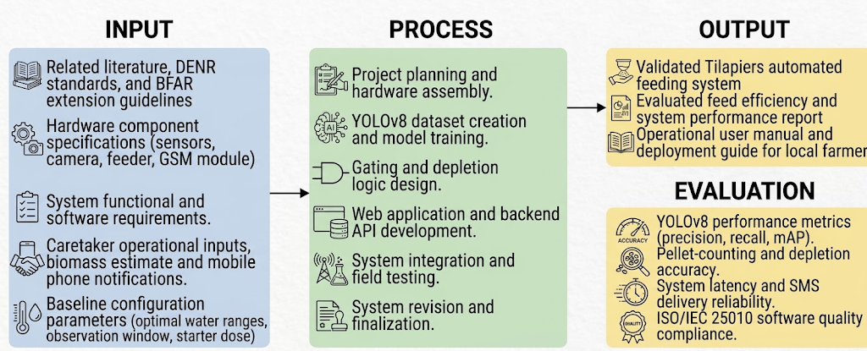
Figure 1 Research Paradigm
This figure illustrates the overall development methodology of the study, describing the major inputs required, the processes involved in designing and developing the system, and the expected outputs and evaluation methods. This framework serves as a guide for the entire research project, specifically to achieve the study's objectives.
The study’s input phase encompasses the foundational data and specifications required to build the system. This includes related literature, water quality standards from DENR Administrative Order No. 2016-08, and BFAR extension guidelines. It also includes hardware component specifications for the sensors, camera, feeder, and GSM module, as well as system functional and software requirements. Furthermore, caretaker operational inputs—such as the stocked biomass estimate and registered mobile phone number—are integrated with baseline configuration parameters (optimal water quality ranges, observation window duration, and reference starter dose) to establish operational boundaries.
The process phase covers the core execution steps involved in developing Tilapiers. These activities begin with project planning and physical hardware assembly, followed by the creation of a custom feed-pellet dataset and YOLOv8 model training. The software development pipeline includes designing environmental gating and depletion-responsive decision logic, as well as web application and backend API development.
Finally, the integrated hardware and software components undergo field testing at an outdoor facility, followed by iterative revisions and finalization. The output phase produces a validated Tilapiers automated feeding system, an evaluated feed efficiency and system performance report, and an operational user manual and deployment guide for local fish farmers. To verify that the system fulfills the research requirements, it undergoes an evaluation phase measuring YOLOv8 object detection performance metrics (precision, recall, mAP), pellet-counting and depletion accuracy, system latency, SMS delivery reliability, and ISO/IEC 25010 software quality compliance.

Conceptual Framework of the Proposed System
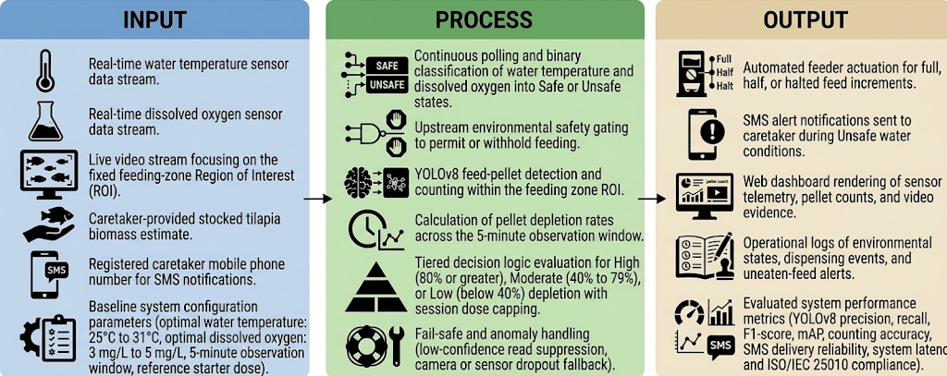
Figure 2 Conceptual Framework
This figure represents the overall conceptual framework of the study, illustrating the relationship between the system inputs, the processing of components, and the expected outputs. To elaborate, this framework maps how real-time environmental data and computer vision streams are processed through automated decision logic to execute precise feeding actions, alert caretakers, and render system telemetry.
The input layer consists of real-time sensor data streams for water temperature and dissolved oxygen, paired with a live video stream focusing on the fixed feeding-zone Region of Interest (ROI). It includes caretaker-provided operational parameters—specifically a stocked tilapia biomass estimate used to establish the reference starter dose and a registered mobile phone number for SMS notifications. These inputs operate within baseline system configuration parameters, including optimal water quality ranges of 25°C to 31°C for water temperature and 3 mg/L to 5 mg/L for dissolved oxygen, a 5-minute observation window, and the pre-calibrated reference starter dose.
The processing layer begins with continuous sensor polling and binary classification of temperature and dissolved oxygen into Safe or Unsafe states, acting as an upstream environmental safety gate that permits or withhold feeding. When permitted, the system engages a YOLOv8 object detection model to detect and count visible feed pellets within the ROI, calculating the pellet depletion rate across the 5-minute observation window. Tiered decision logic then evaluates this depletion rate as High (80% or greater), Moderate (40% to 79%), or Low (below 40%) to govern feed dispensing under a strict session dose ceiling. This layer also incorporates fail-safe and anomaly handling mechanisms to suppress low-confidence reads and manage camera or sensor dropouts.
The output layer encompasses the physical actions, web telemetry, operational records, and system evaluation results. Automated feeder actuation executes full, half, or halted feed increments based on the decision logic, while instant SMS alerts notify the caretaker during Unsafe water conditions. Simultaneously, the web dashboard renders real-time sensor telemetry, pellet counts, and video evidence, while maintaining operational logs of environmental states, dispensing events, and uneaten-feed alerts. Finally, the system yields benchmarked performance metrics, including YOLOv8 object detection performance (precision, recall, F1-score, mAP), pellet-counting accuracy, SMS delivery reliability, system latency, and ISO/IEC 25010 software quality compliance.

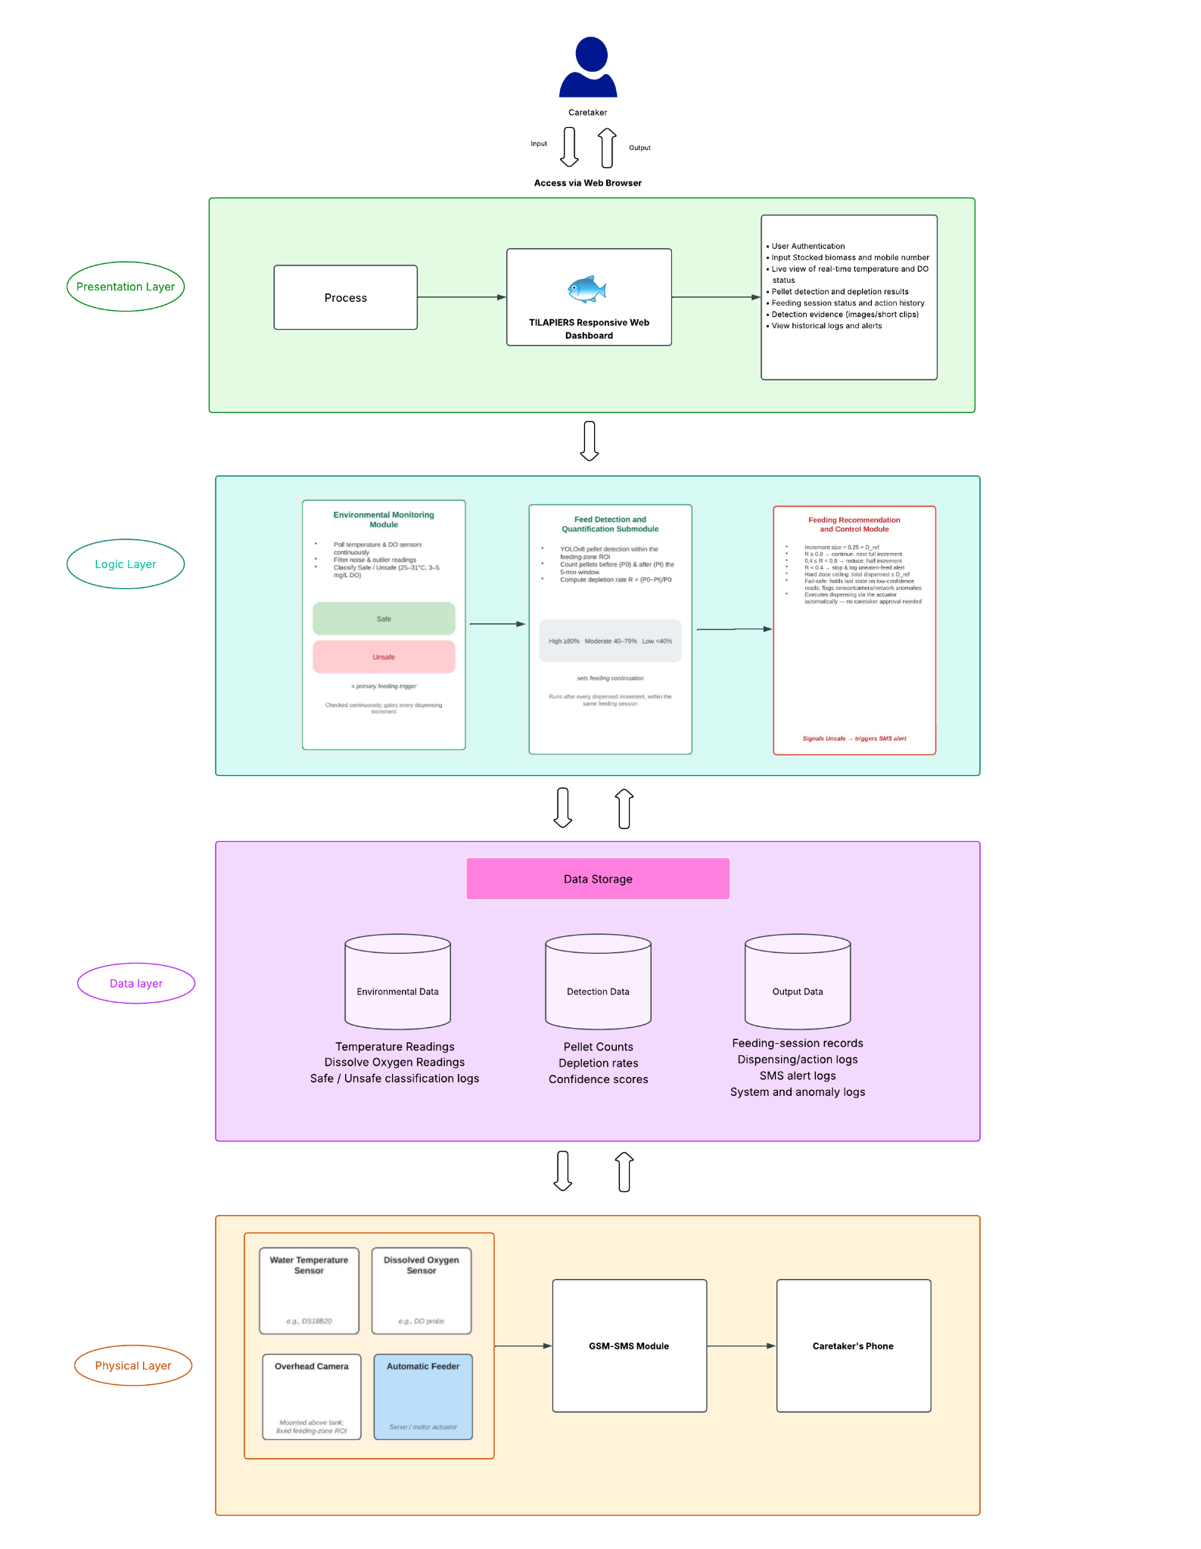
Figure 3 System Architecture

The Tilapiers system architecture is organized into four interconnected layers: the Presentation Layer, Logic Layer, Data Layer, and Physical Layer. The Presentation Layer serves as the caretaker-facing Web Interface through the Web-Based Dashboard and Alert Module, where the caretaker provides setup information such as the stocked biomass estimate and registered mobile number and views environmental status, pellet detection results, feeding-session history, and detection evidence through HTTPS API requests. The dashboard is updated in real time as new results are generated by the Logic Layer. The Logic Layer, hosted on the Application Server, serves as the operational core of the system and consists of three cooperating modules. First, the Environmental Monitoring Module continuously collects and filters temperature and dissolved-oxygen readings and determines whether the environment is Safe or Unsafe based on the study's baseline ranges of 25°C–31°C for temperature and 3–5 mg/L for dissolved oxygen. This environmental assessment serves as the primary feeding trigger. If either parameter is outside the acceptable range, the system classifies the environment as Unsafe, holds the feeding process, and signals the Alert Module to send an SMS notification to the registered caretaker. If both parameters are within the acceptable ranges, the environment is classified as Safe and the feeding process is permitted to proceed. The Feed Detection and Quantification Submodule then applies YOLOv8 to detect and count pellets within the feeding-zone region of interest immediately after dispensing (P₀) and again after a five-minute observation period (Pₜ), allowing the system to calculate the pellet depletion rate using R = (P₀−Pₜ)/P₀. The Feeding Recommendation and Control Module then evaluates the resulting depletion rate and determines the next feeding action. A High depletion rate (≥80%) results in the full next feeding increment, a Moderate depletion rate (40%–79%) results in a reduced feeding increment, and a Low depletion rate (<40%) results in stopping the feeding adjustment and maintaining the current feeding level. Feeding is dispensed in fixed increments of 0.25 × D_ref and remains subject to a strict session dose ceiling. The Logic Layer also implements fail-safe mechanisms, such as holding the current state when sensor or detection readings have low confidence and flagging detected anomalies for monitoring. The Data Layer, hosted on the Database Server, stores the information generated by the Logic Layer and retrieved by the Presentation Layer, including Environmental Data consisting of temperature and dissolved-oxygen readings and Safe/Unsafe history; Detection Data consisting of pellet counts, depletion rates, and confidence scores; and Output Data consisting of feeding-session records, dispensing and action logs, SMS alert logs, and system or anomaly logs. Finally, the Physical Layer consists of the field devices deployed at the tilapia pond or tank, including the water-temperature and dissolved-oxygen sensors, the overhead feeding-zone camera that provides visual data for pellet detection, the automatic feeder actuator that executes dispensing actions, and the GSM/SMS module that sends alerts directly to the caretaker's registered mobile number independently of the Web Interface. Together, these four layers enable Tilapiers to collect real-time environmental and feeding data, verify whether conditions are suitable for feeding, quantify pellet depletion, determine the appropriate feeding action, record system outputs, and provide the caretaker with real-time monitoring and SMS alerts.

System Flowchart
The system flowchart outlines the primary operational workflow of Tilapiers, beginning with user authentication and main menu navigation. It manages a continuous environmental monitoring pipeline that tracks water temperature and dissolved oxygen levels to verify whether water conditions meet optimal safety thresholds prior to scheduled feeding sessions. If parameters fall outside safe ranges, the system halts feeding and sends SMS alerts to caretakers. When conditions are optimal, the feeding module dispenses an initial starter dose and dynamically adjusts, reduces, or stops feed delivery based on observed fish appetite levels.
Beyond automated feeding and sensing, the architecture incorporates administrative management, system maintenance, and data security features. The profile management module handles user account authorization, staff archiving, and role assignments. System security is maintained through database backup and restoration routines, while an automated maintenance module dispatches routine SMS cleaning reminders to caretakers. Lastly, dedicated FAQ and system information modules provide operational guidance to support long-term usability.
All environmental readings, feeding logs, and administrative actions are systematically stored in a central database to maintain a complete operational history. This centralized data pipeline allows the web application to present real-time monitoring updates and issue automated SMS alerts to caretakers. Ultimately, the unified workflow connects continuous sensor gating with active user oversight to optimize feed usage and protect water quality.

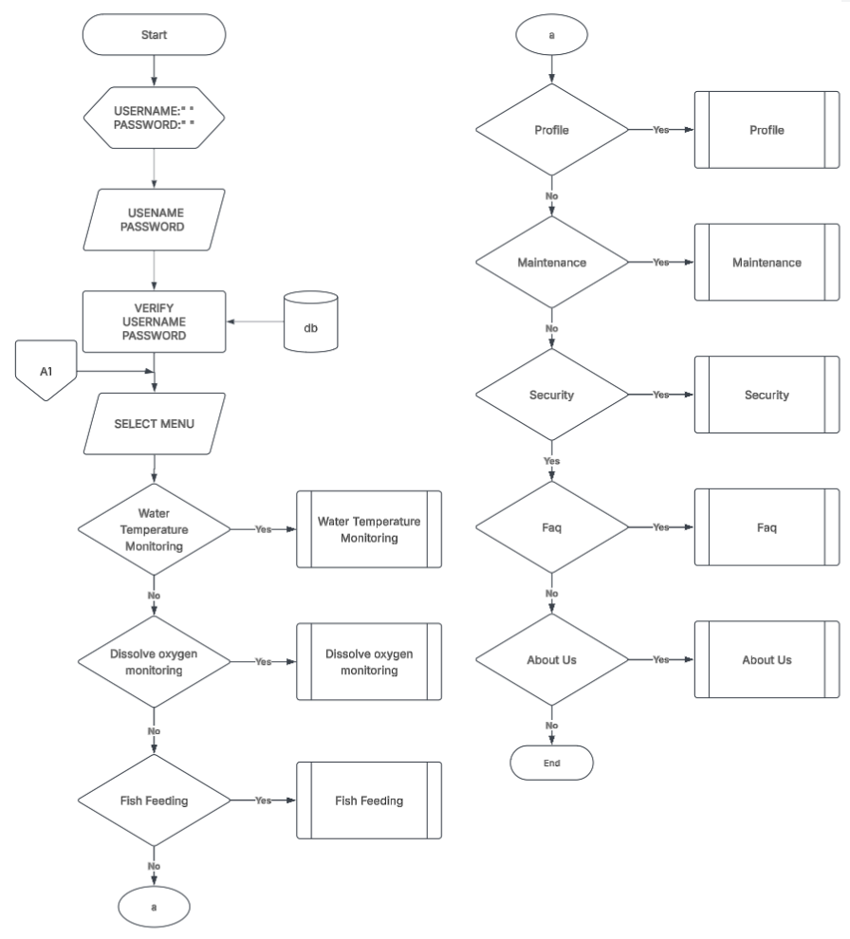
Figure 4 Main Menu Module
The main menu module authenticates user credentials against the database before granting access to primary system features. Upon successful verification, users can navigate to water parameter monitoring, fish feeding controls, user profile settings, system maintenance, security options, FAQs, or system information.
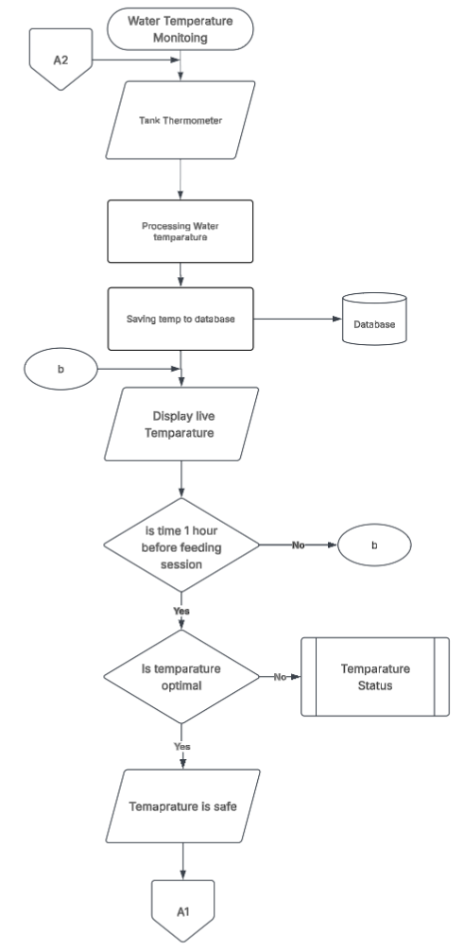
Figure 5 Water Temperature Monitoring Module
This module reads raw data from the tank thermometer, processes the values, and saves continuous temperature records to the database for live display. Exactly one hour before a scheduled feeding session, it evaluates whether the water temperature falls within optimal ranges before declaring the state safe or redirecting to status validation.

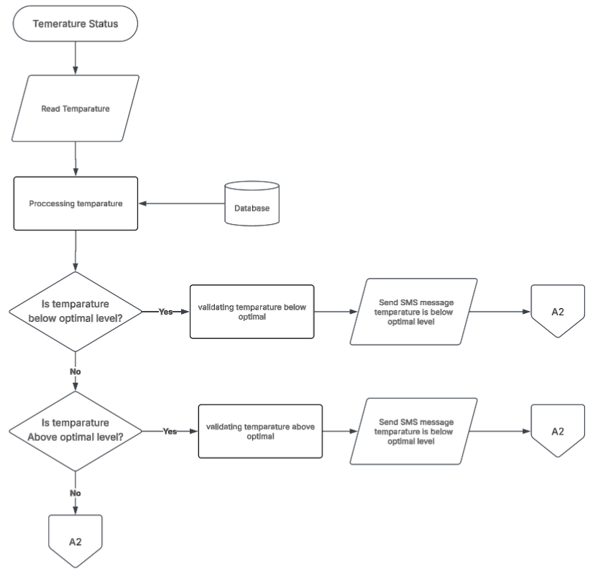
Figure 6 Temperature Status Module
The temperature status module checks stored water temperature data to determine whether readings have fallen below or risen above safe threshold levels. If an abnormal thermal state is detected, the system validates the reading and dispatches an automated SMS alert to notify caretakers of the sub-optimal condition.
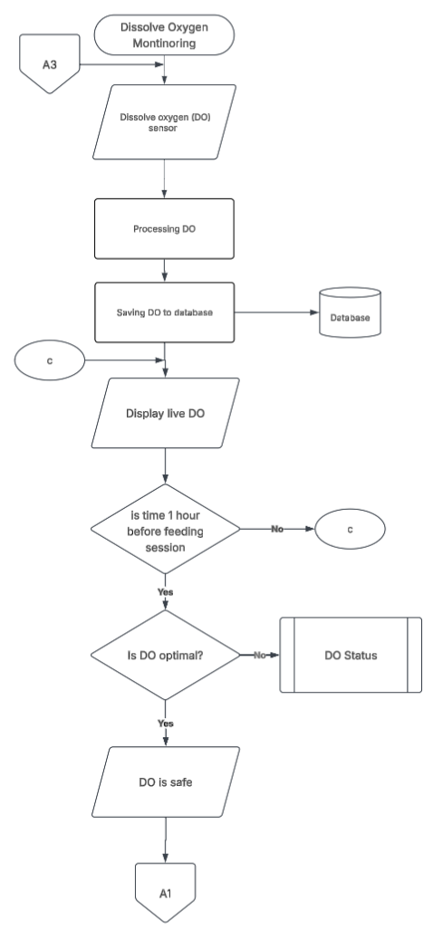
Figure 7 Dissolved Oxygen Monitoring Module
This module acquires dissolved oxygen levels from the tank sensor, processes the reading, and updates the central database to display live DO metrics. Prior to feeding, it assesses whether oxygen levels meet the required operational threshold and redirects the system to status handling if DO levels are inadequate.
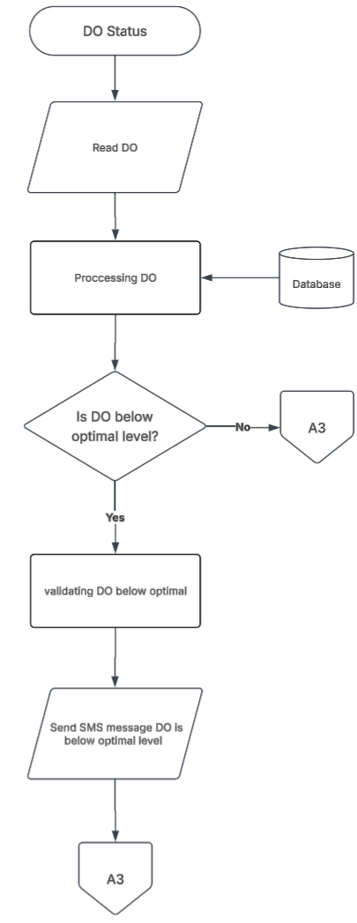
Figure 8 DO Status Module
The DO status module evaluates oxygen measurements against optimal biological requirements to identify hypoxic or unsafe conditions. When dissolved oxygen falls below the required threshold, the system validates the alert and immediately transmits an SMS warning to the caretaker.
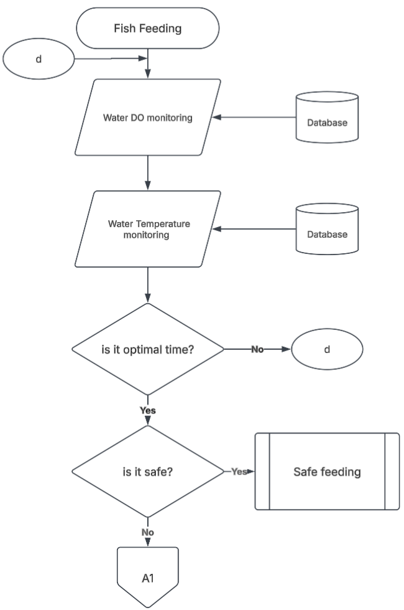
Figure 9 Fish Feeding Evaluation Module
This module retrieves water temperature and dissolved oxygen data from the database to check if environmental conditions and scheduled feeding times align. If both environmental gating checks pass successfully, the workflow proceeds to execution, whereas unsafe conditions halt the feeding sequence and return to the main menu.

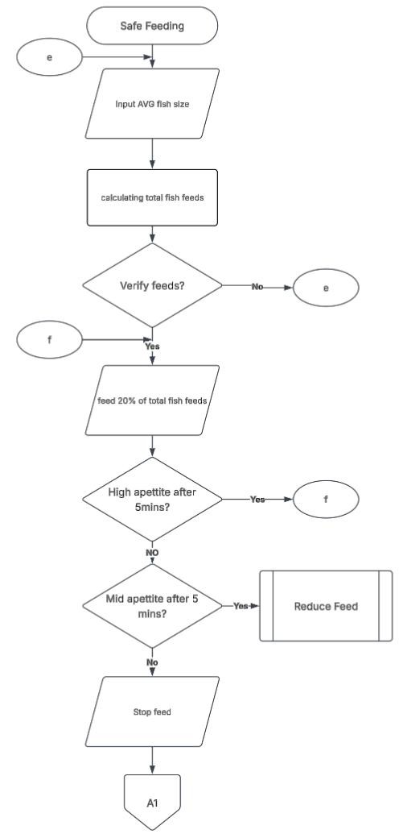
Figure 10 Safe Feeding Execution Module
Once safe feeding is confirmed, the system calculates total feed requirements based on average fish size and dispenses an initial 20% starter ration. It monitors fish appetite over five-minute intervals, continuing incremental feeding for high appetite, triggering feed reduction for moderate appetite, or stopping feed if no activity is observed.
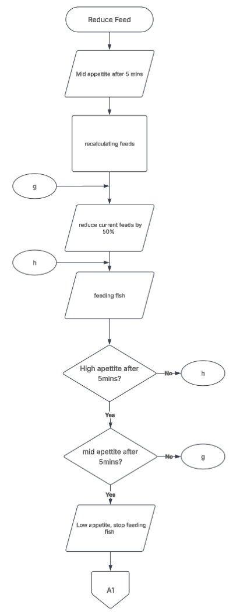
Figure 11: Reduce Feed Module
The reduce feed module recalculates remaining feed quantities and cuts the active ration by 50% when moderate fish appetite is observed. It re-evaluates fish feeding behavior after five minutes to either adjust dosing further or completely terminate feeding if consumption drops.
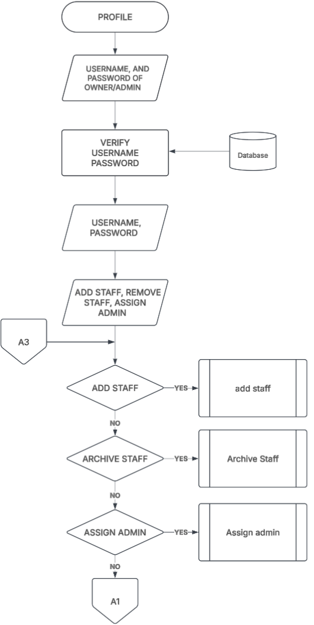
Figure 12 Profile Management Module
The profile module verifies administrator login credentials to authorize system management tasks. Once authenticated, administrators can choose to add new staff accounts, archive existing employee profiles, or reassign admin privileges.
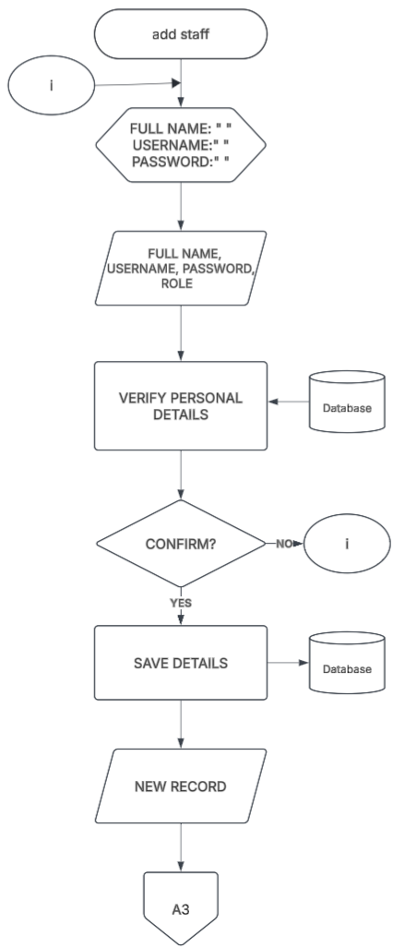
Figure 13 Add Staff Module
This module collects full name, username, password, and assigned role for new system users and verifies these personal details against the database. Upon confirmation, the new account details are saved to the database, generating a new user record for system access.
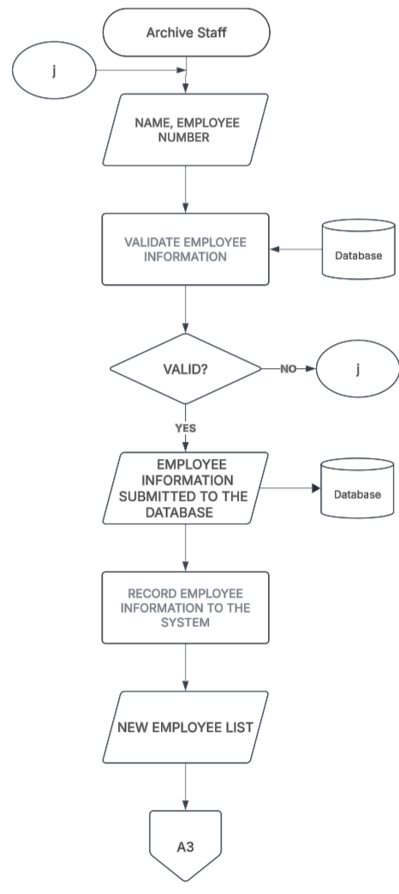
Figure 14 Archive Staff Module
The archive staff module processes employee identification details and validates them against current database records. Once validated, the selected employee profile is archived and saved in the system to maintain an updated active staff list.
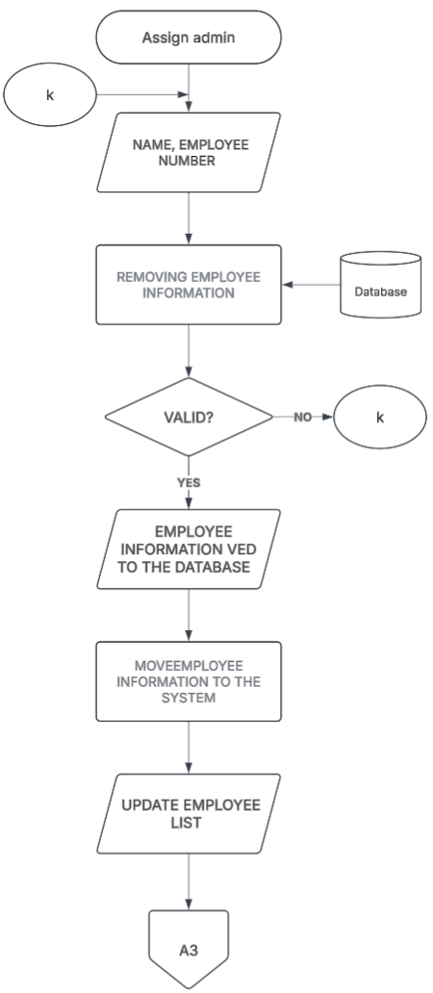
Figure 15 Assign Admin Module
This module prompts for employee information to modify system administrative roles within the central database. After validating the user details, it updates user permission levels and saves the revised administration list.
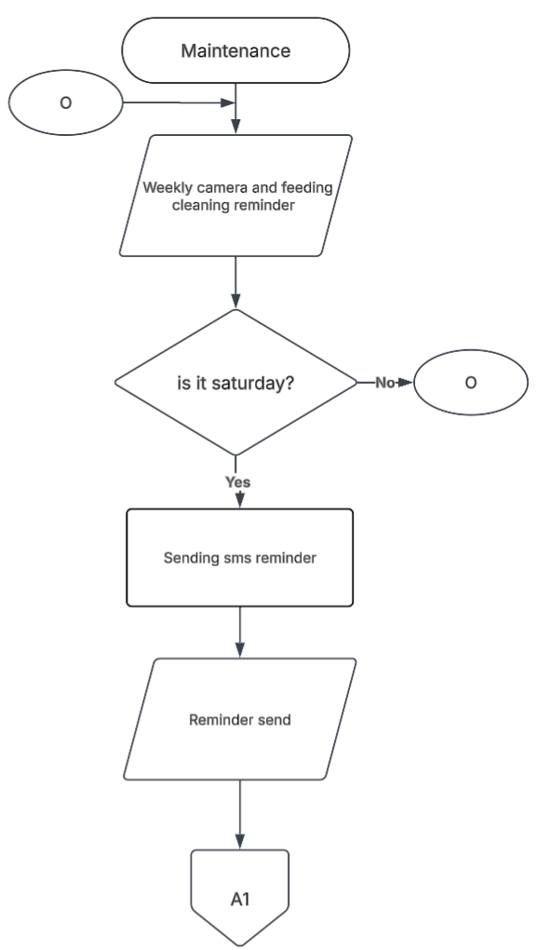
Figure 16 Maintenance Module
The maintenance module manages routine physical upkeep by evaluating weekly operational schedules for cleaning cameras and feeding hardware. On designated Saturdays, the system automatically triggers and transmits an SMS maintenance reminder to system operators.
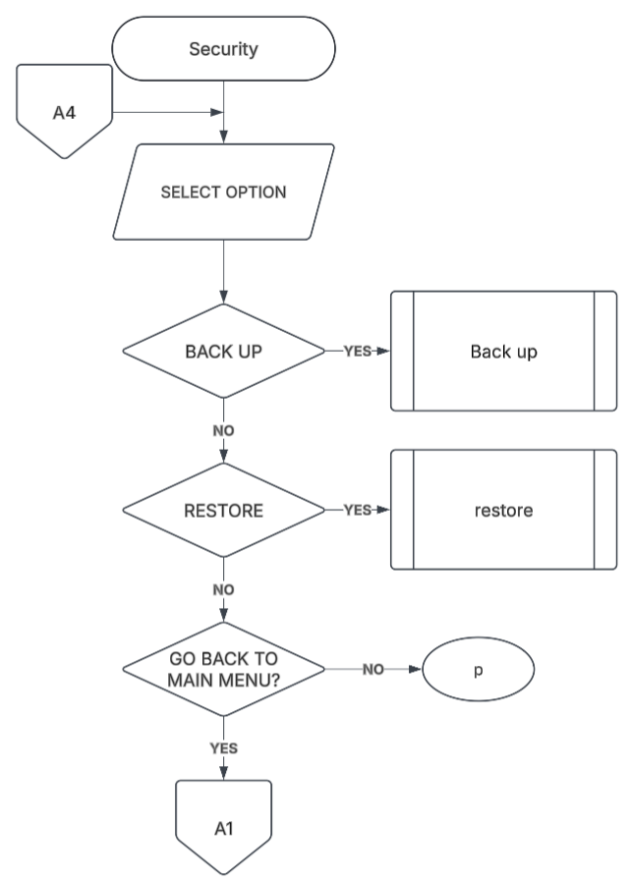
Figure 17 Security Module
The security module provides administrators with menu options to execute system data backups, restore prior database states, or return to the main navigation menu. It routes user selections to dedicated backup and restoration sub-processes to safeguard critical operational logs.
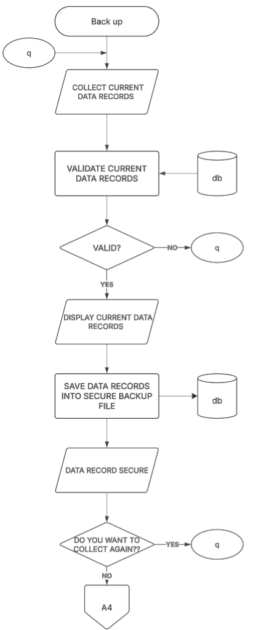
Figure 18 Backup Module
The backup module aggregates current data logs, validates database records, and renders them on screen for user review. Verified records are compiled into a secure backup file in the database, with an option to repeat data collection or exit back to the security menu.
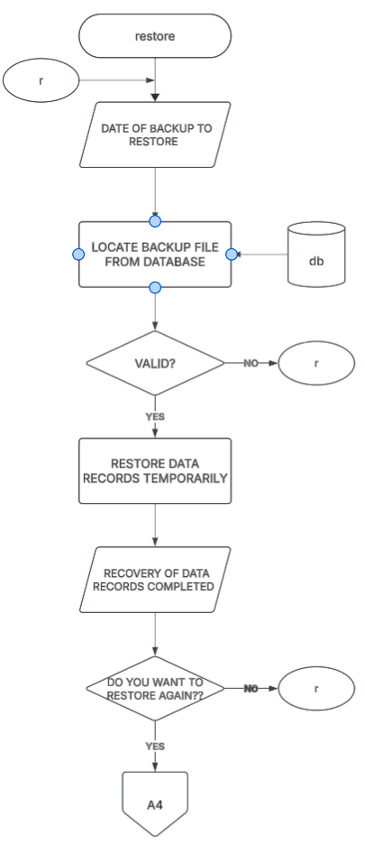
Figure 19 Restore Module
This module allows administrators to select a specific backup date and locates the corresponding archive file within the database. Once validated, it temporarily restores data records and completes system recovery before prompting the user to finish or repeat the process.
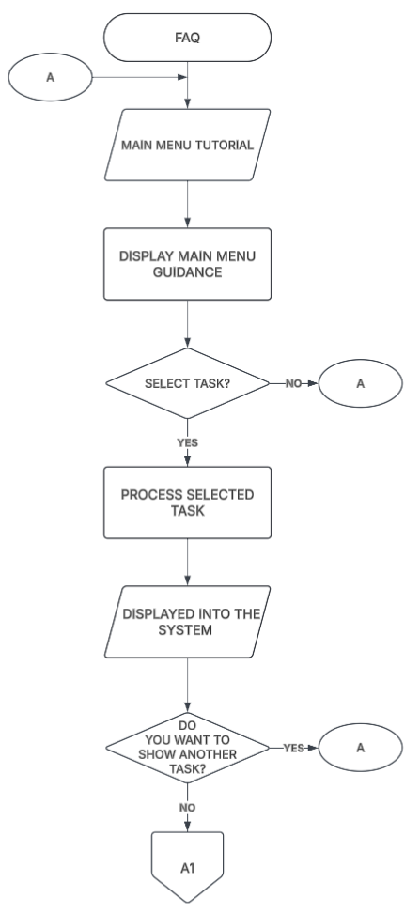
Figure 20 FAQ Module
The FAQ module displays interactive guidance and tutorials covering the operation of various system menu tasks. Users can select specific tasks to process instructional guidance on screen with the option to view additional operational tutorials.
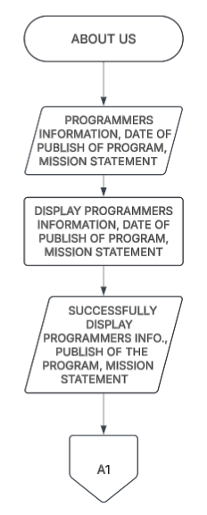
Figure 21 About Us Module
The About Us module retrieves programmer information, program publication dates, and system mission statements. It renders these details clearly on the screen before returning the user to the main menu routing interface.
CHAPTER 3
Research Methodology
This chapter presents the research methodology and operational framework used in the design, development, and evaluation of Tilapiers, the environment-gated, depletion-responsive automated feeding system for Nile tilapia introduced in Chapter 1. As the study is classified as technical developmental research, this chapter is organized around the five methodological components prescribed for this research type: Project Design, Project Development, Testing and Operating Procedure, Project Evaluation, and Work Plan. Consistent with the requirement that computing standards and modern tools and techniques be integrated throughout the methodology rather than treated as an isolated topic, each section identifies the specific standards, frameworks, and development tools applied at that stage of the project. The chapter closes with a discussion of the system's potential for commercialization, covering its market model, measurable benefits, three-year product roadmap, go-to-market strategy, and business model.

Research Design
This study follows a technical developmental research design, appropriate for projects whose primary output is a working hardware-software system rather than a statistically generalizable conclusion drawn from a sampled population. Development proceeds under an Iterative and Incremental Development (IID) model, in which the environmental gating logic, the YOLOv8 detection pipeline, the feeding decision algorithm, and the web dashboard are each built, tested, and refined across successive short cycles rather than in a single linear pass. This model was selected over a strict Waterfall approach because Tilapiers integrates hardware calibration, a trained computer vision model, and control software whose parameters (e.g., detection-confidence thresholds, depletion-rate cut-offs) cannot be finalized analytically and instead require empirical tuning against pilot data — a pattern of iterative refinement more compatible with incremental delivery and short feedback loops than with a design that treats requirements as fixed from the outset.
The physical build of the system additionally follows the standard engineering design process (problem definition, requirement specification, conceptual design, detailed design, prototyping, testing, and iteration) to co-develop the sensor, actuator, and camera subsystems alongside the software modules. Agile-inspired sprint planning (two-week iterations, sprint backlogs, and end-of-sprint review) is used to sequence development tasks across both hardware and software workstreams, described further in Section 3.4.
Unit of Analysis. The unit of analysis is the Tilapiers system as an integrated hardware-software prototype — specifically, its performance on the technical benchmarks defined in Chapter 1, Objective 5 (object detection performance, pellet-counting and depletion accuracy, environmental classification accuracy, SMS delivery reliability, recommendation-to-execution latency) and its perceived quality as rated by evaluators using the ISO/IEC 25010 instrument described in Section 3.6. This is distinct from a social-science unit of analysis such as an individual respondent; here, the respondents are evaluators of a single system under test, not independent subjects being compared to one another.
Subjects and Sample Size. Because this is a developmental study evaluated through expert and end-user judgment rather than a population survey, subjects were selected through purposive sampling rather than probability sampling. A total of thirty (30) evaluators are targeted, distributed across three respondent groups of ten (10) each: (1) IT/software engineering experts competent to assess software quality characteristics under ISO/IEC 25010; (2) aquaculture technical personnel, including BFAR-NCR Fisheries Production Section staff, competent to assess the system's alignment with field feeding practice and water-quality standards; and (3) prospective end users — small-scale tilapia farmers and hobbyists — competent to assess the system's usability and practical value. This tri-group composition is intended to triangulate technical soundness, domain fidelity, and practical usability, consistent with the study's Significance section in Chapter 1.
Project Design
Project design specifies the concrete hardware and software features implementing the operational modules defined in the system flowchart (Chapter 1, Figures 4–21), and the standards each component must satisfy. Unlike the five broad conceptual modules used to describe the system at a high level in Chapter 1's Conceptual Framework, Table 3.1 below reflects the actual module decomposition shown in the flowchart, including the navigation, environmental-status, feeding, and administrative modules the caretaker interacts with directly. The YOLOv8-based pellet-detection and depletion-responsive dosing logic reviewed in Chapter 2 is retained as the underlying decision engine and is implemented within the Fish Feeding Evaluation and Safe Feeding Execution modules described below.

Module | Hardware / Software Components | Design Basis and Standards
Main Menu and Authentication Module | Web front-end login screen; backend credential-verification service; session management. | Standard username/password authentication against the relational database; access gating for all downstream modules.
Water Temperature Monitoring Module | Waterproof digital temperature probe; MCU for polling and pre-filtering; live-display dashboard component. | Continuous polling and live logging; one-hour pre-feeding evaluation window; threshold bands validated against DENR AO 2016-08 Class C freshwater standards and BFAR-NCR field consultation (Table 1, Chapter 1).
Temperature Status Module | Backend validation logic; SIM800L-class GSM/SMS module. | Flags below-/above-optimal readings against the calibrated threshold band; triggers SMS alert to the caretaker's registered number on an abnormal reading.
Dissolved Oxygen Monitoring Module | Galvanic or optical DO sensor; MCU for polling and pre-filtering; live-display dashboard component. | Continuous polling and live logging; one-hour pre-feeding evaluation window; threshold bands per DENR AO 2016-08 and pilot calibration.
DO Status Module | Backend validation logic; SIM800L-class GSM/SMS module. | Flags below-optimal DO readings against the calibrated threshold; triggers SMS alert on a hypoxic/unsafe reading.
Fish Feeding Evaluation Module | Server-side gating logic reading the latest stored temperature and DO classifications. | Deterministic rule-based gate: feeding proceeds only when both the Temperature Status and DO Status checks return Safe; otherwise the session is halted and logged.
Safe Feeding Execution Module | Fixed-position camera aimed at the feeding-zone ROI; single-board/edge-AI unit running a YOLOv8n model (Ultralytics framework, PyTorch backend); actuator (auger- or servo-driven feeder) triggered via relay/GPIO. | Model architecture per Jocher et al. (2023); pellet-centered detection approach adapted from Riyandani et al. (2023). Dispenses the fixed reference starter dose in fixed-size increments, computing pellet-depletion rate R = (P0 - Pt)/P0 over the 5-minute observation window and classifying it High/Moderate/Low (Table 2, Chapter 1).
Reduce Feed Module | It shares the Safe Feeding Execution Module's camera/YOLOv8 pipeline and actuator. | Triggered when depletion is classified Moderate; halves the active increment and re-evaluates depletion after the next 5-minute window, continuing, further reducing, or stopping per the same tiered logic.
Web-Based Dashboard and Alert Sub-layer | Front-end single-page application; backend REST/WebSocket API; shared across all monitoring and feeding modules. | Responsive UI design; real-time telemetry via MQTT; renders environmental status, pellet-detection results, feeding-session status, and SMS logs.
Profile Management Module | Admin authentication check; staff-record CRUD operations (Add Staff, Archive Staff, Assign Admin) against the relational database. | Role-based access control for administrative functions; changes logged for auditability.
Maintenance Module | Scheduled task runner; SIM800L-class GSM/SMS module. | Weekly (Saturday) automated SMS reminder for camera and feeder cleaning, independent of the feeding decision logic.
Security Module | Backup/Restore sub-processes against the relational database. | Scheduled and on-demand data backup and restoration of environmental, feeding, and administrative records.
FAQ and About Us Modules | Static/semi-static content rendering from the database. | Operational guidance and system-information display; no interaction with sensor or feeding logic.
Table 3 System Features and Design Basis by Operational Module

Computing Standards, Modern Tools, and Techniques
Consistent with the requirement to integrate computing standards and modern development tools and techniques throughout the operational framework, Table 3.2 consolidates the standards, frameworks, and tools applied across the project, indicating the methodological stage at which each is used. Later sections reference this table rather than restating each standard in full.
Standard / Tool / Technique | Applied In | Purpose
ISO/IEC 25010:2011 (Software Product Quality Model) | Project Evaluation (3.6); Testing (3.5) | Defines the eight quality characteristics (functional suitability, performance efficiency, compatibility, usability, reliability, security, maintainability, portability) used to structure both non-functional testing and the expert/end-user evaluation instrument.
ISO/IEC/IEEE 29148 (Requirements Engineering) | Project Development, Phase 1 (3.4.1) | Structures the software/hardware requirements specification (SRS) produced during requirements gathering with BFAR-NCR.
ISO/IEC/IEEE 29119 (Software Testing) | Testing and Operating Procedure (3.5) | Provides the vocabulary and process structure for unit, integration, system, and acceptance test levels.
DENR Administrative Order No. 2016-08 | Project Design (3.2); environmental threshold calibration | Reference water-quality standard for Class C freshwater used to bound the Safe/Unsafe classification bands.
Agile/Scrum (two-week sprints) | Project Development (3.4) | Iterative delivery cadence for both hardware assembly and software increments; sprint backlog and review cycle.
Git / GitHub (version control) | Project Development (3.4) | Source-code management, branching, and collaborative review across the four-member development team.
Roboflow / LabelImg (dataset annotation) | Project Development, Phase 3 (3.4.3) | Bounding-box annotation of feed-pellet images for YOLOv8 training; dataset versioning and augmentation.
Ultralytics YOLOv8 framework (PyTorch) | Project Development, Phase 4 (3.4.4) | Transfer-learning and fine-tuning of the pellet-detection model; export to an inference-optimized format for edge deployment.
RESTful API design (OpenAPI 3.0) | Project Development, Phase 5 (3.4.5) | Standardized, documented contract between the decision engine, dashboard, and actuator firmware.
MQTT protocol | Project Development, Phase 5 (3.4.5) | Lightweight publish-subscribe messaging for real-time sensor telemetry to the dashboard.
Docker containerization | System Integration (3.4.6); Deployment | Environment consistency between development machines and the field-deployed backend.
CI/CD pipeline (GitHub Actions) | Testing (3.5) | Automated build, lint, and regression-test execution on every code change prior to field deployment.
Table 4 Computing Standards, Tools, and Techniques Applied Across the Methodology

Project Development
The researchers will adopt the V-model as the development methodology for Tilapiers. The system combines hardware sensing and actuation, a computer vision model, a rule-based feeding decision algorithm, and a web application, and its behavior directly affects the fish (feeding permission, dose ceiling, and fail-safe responses). A model that pairs every development stage with a corresponding level of testing allows the test criteria for each stage to be defined before implementation begins and ensures that each requirement and design decision is verified and validated. As illustrated in Figure , the left arm of the V covers the development stages (requirements analysis, system design, module design, and implementation), while the right arm covers the corresponding testing levels (unit testing, integration testing, system testing, and acceptance testing). Each design stage is linked horizontally to the testing level that verifies it, and the process concludes with final deployment. Table _ summarizes these correspondences.

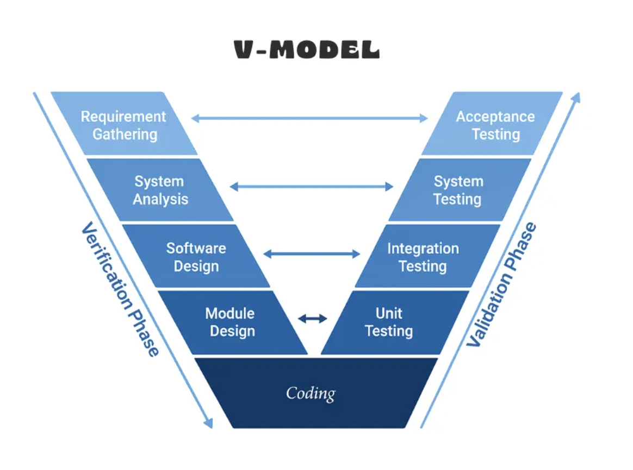

Figure 22 V-Model Diagram

Requirement Gathering
In the requirement gathering stage, the researchers will consult stakeholders and reference sources to collect the raw requirements of the Tilapiers system. This includes identifying the target species and growth stage (adult Nile tilapia at the finisher stage), the outdoor tank setup at the BFAR-provided facility, the applicable threshold sources (peer-reviewed literature, the BFAR-NCR field consultation, and DENR Administrative Order No. 2016-08), and the hardware requirements (water-temperature sensor, dissolved-oxygen sensor, camera module, microcontroller, computer vision processing unit, automatic feeder actuator, and SMS/GSM module) and software requirements (web application, backend API, and dashboard) needed to meet stakeholder needs.
System Analysis
In the system analysis stage, the researchers will analyze the gathered requirements to define the system-level specifications of Tilapiers. This includes specifying the two environmental parameters used by the verification gate (water temperature and dissolved oxygen), the feeding-zone region of interest (ROI), the image dataset required for feed-pellet detection, and the observation window and depletion-rate tiers that govern the feeding decision. The acceptance criteria against which the completed system will be judged are also defined at this stage.
Software Design
In the software design stage, the researchers will develop the overall architecture and workflow of the system. The workflow will include continuous sensor polling, sensor-reading validation, binary Safe/Unsafe environmental classification, SMS alerting for Unsafe states, incremental feed dispensing, feeding-zone image capture, YOLOv8-based feed-pellet detection and counting, pellet-depletion rate computation, tiered depletion classification, feeding action execution, and logging with dashboard presentation. The physical layout will also be designed, including the placement of the temperature and dissolved-oxygen probes, the fixed camera position and lighting over the feeding-zone ROI, and the position of the feeder relative to the ROI. The fail-safe and anomaly-handling rules, including the hard session dose ceiling, will likewise be defined at this stage. The system test cases are prepared alongside this design.
Module Design
In the module design stage, the researchers will specify the internal design of each module and the interfaces between them. The modules include the environmental monitoring module, the feed detection and quantification submodule, the feeding recommendation and control module, the web-based dashboard and alert module, and the system maintenance and logging module. The specification covers the dataset and annotation scheme and the YOLOv8 configuration for pellet detection, the threshold bands and the depletion-responsive decision rules, the data exchanged between the microcontroller, the computer vision processing unit, the actuator, the SMS module, and the web application, and the layout and content of the dashboard. The integration test cases are prepared alongside this design.
Coding
At the base of the V, the researchers will implement the modules specified in the module design. This includes assembling the hardware pipeline, capturing and annotating the feed-pellet image dataset, training the YOLOv8 model, implementing the environmental verification gate, coding the depletion-responsive feeding decision algorithm, configuring the feeder actuator and SMS/GSM module, and developing the backend API and web dashboard. Within this stage, model training involves repeated tuning of training settings against the validation set, as described under Model Training and Parameter Configuration. The unit test cases are prepared alongside the coding stage.
Unit Testing
Unit testing verifies each component individually against the module design. The temperature and dissolved-oxygen sensors will be checked against reference instruments. The YOLOv8 model will be evaluated on test images that were not used during training, using Precision, Recall, F1-score, Intersection over Union (IoU), and Mean Average Precision (mAP), and its pellet counts will be compared with manually verified ground truth. The environmental gate will be tested with readings at and around the threshold boundaries, and the decision algorithm will be tested with simulated pellet counts covering the High, Moderate, and Low depletion tiers and the session dose ceiling. The feeder, SMS module, and dashboard components will also be tested individually.
Integration Testing
Integration testing verifies that the modules work together as defined in the module design. The researchers will test the flow of readings from the sensors through the microcontroller to the environmental gate, the flow of camera frames to the detection model and of pellet counts to the decision algorithm, the transmission of feeding commands to the actuator, the triggering of SMS alerts by the Unsafe state, and the transfer of readings, counts, detection evidence, and logs to the backend and dashboard. Timing, message formats, and handling of missing or delayed data at these interfaces will be examined.
System Testing
System testing verifies the fully integrated system against the software design. Functional testing will confirm the correct operation of sensor acquisition, the environmental gate, incremental dispensing, tiered depletion response, the session dose ceiling, SMS alerting, and dashboard presentation, including simulated fault conditions such as invalid sensor readings, camera dropout, and network failure. Pellet-counting and feed-depletion accuracy will be assessed against manually verified ground truth, environmental classification accuracy against reference-instrument readings, and SMS delivery reliability and recommendation-to-execution latency from the system logs.
Acceptance Testing
Acceptance testing validates the system against the requirements gathered and analyzed at the start. The completed system will be operated at the BFAR-provided outdoor tank facility to determine whether it meets the defined acceptance criteria under actual conditions, and its software quality will be evaluated based on ISO/IEC 25010. The results will be compared with the objectives of the study to determine whether the system is ready for deployment.
Defect Traceability and Revision
Defects and shortfalls identified at each testing level will be traced back to the corresponding stage on the left arm of the V. A failed unit or acceptance criterion, for example, points to the coding or requirement-gathering/system-analysis stage, respectively, while an interface fault found during integration testing points to the module design, and a fault found during system testing points to the software design. Errors in pellet detection (such as bubbles, fish waste, or reflections counted as pellets, or pellets missed because of occlusion or clustering), discrepancies between system-computed and manually verified depletion, misclassification of the environmental state, and failed or delayed SMS alerts will be analyzed to identify the affected stage. Corrections may include expanding or correcting dataset annotations, retraining or adjusting the detection model, recalibrating the sensors, refining the threshold bands or depletion-rate thresholds through pilot calibration, adjusting the confidence threshold or ROI definition, improving fail-safe handling, or modifying the interface. The corrected components will then be retested at the affected level and at the levels above it until the acceptance criteria are satisfied.

Final Deployment
After the system satisfies the acceptance criteria, the final version of Tilapiers will be prepared for deployment at the BFAR-provided outdoor tank facility. Prior to operation, the sensor calibration, camera position, and ROI definition will be verified; the feeder will be checked for correct dispensing of the fixed-size increment; the SMS module will be confirmed to deliver alerts to the caretaker's registered mobile number; and the web dashboard will be checked for accessibility on supported browsers and devices. The caretaker will then enter the stocked biomass estimate to establish the reference starter dose, and an operational user manual and deployment guide will be prepared to support local fish farmers.

Multiple Constraints and Trade-off Analysis

Constraints Definition
This section presents the constraints applied in validating the proposed feed-pellet detection and consumption-responsive feeding system. The constraints cover the detection performance of the YOLOv8 model (Precision, Recall, F1-score, IoU, mAP, and inference speed) and the system-level performance of the feeding pipeline (pellet-counting accuracy, depletion classification accuracy, environmental classification accuracy, SMS delivery reliability, and recommendation-to-execution latency).

Precision
Precision measures how reliable the model's positive predictions are. It shows how many of the objects identified by the model as feed pellets are actually pellets. For Tilapiers, high precision means that bubbles, fish waste, reflections, and fish are rarely counted as pellets, which prevents residual pellets from being overcounted and depletion from being underestimated.
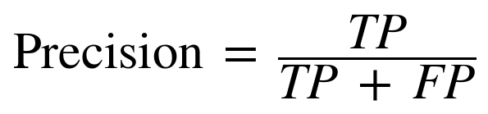
Where:
TP = True Positives; feed pellets correctly detected
FP = False Positives; non-pellet objects incorrectly detected as pellets

Recall
Recall measures how well the model finds all the actual feed pellets present in the ROI. A high recall is important for Tilapiers because pellets missed by the detector in the post-window count would make depletion appear greater than it actually is, which could lead to continued feeding when uneaten feed remains.
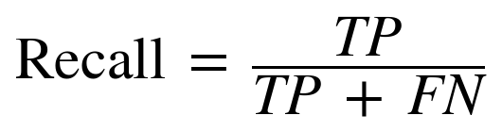
Where:
TP = True Positives; feed pellets correctly detected
FN = False Negatives; actual feed pellets that the model failed to detect

F1-score
The F1-score is the harmonic mean of Precision and Recall. It provides a single measure of detection performance that penalizes a model that achieves one metric at the expense of the other.
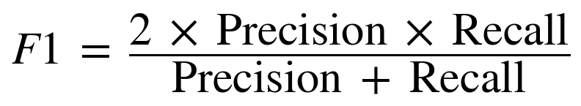

Intersection over Union (IoU)
IoU measures how closely a predicted bounding box overlaps the manually annotated bounding box. A detection is counted as a true positive when its IoU with a ground-truth pellet meets the specified IoU threshold.
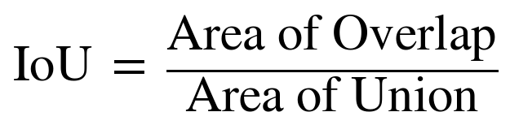

Mean Average Precision (mAP)
Mean Average Precision summarizes detection performance across confidence thresholds by averaging the Average Precision (AP), the area under the Precision–Recall curve, over the detected classes. Because the model is trained on a single feed-pellet class, mAP reduces to the AP of that class and will be reported at IoU = 0.50 (mAP@0.5) and, where applicable, averaged over IoU thresholds from 0.50 to 0.95 (mAP@0.5:0.95).
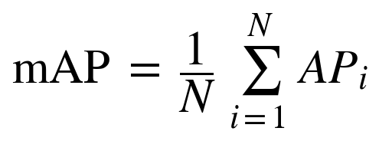
Where:
N = number of classes
AP_i = Average Precision of class i

Inference Speed
Inference speed refers to how quickly the trained model processes a frame and returns pellet detections, expressed in milliseconds per frame (or frames per second) on the deployed processing unit. Because each feeding decision is based on pellet counts taken across a five-minute observation window, the model is not required to run at high frame rates; it must, however, process frames quickly enough to produce the pellet counts and dashboard evidence without delaying the feeding decision.

Pellet-Counting Accuracy
Pellet-counting accuracy measures how closely the number of pellets counted by the system matches the manually verified number of pellets in the same frame.
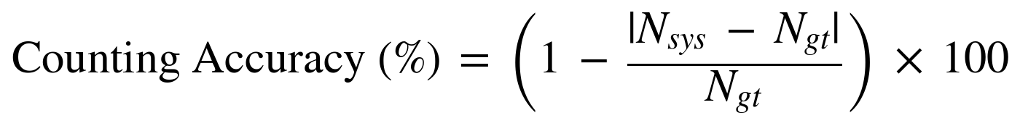
Where:
N_sys = number of pellets counted by the system
N_gt = manually verified number of pellets

Depletion Classification Accuracy
Depletion classification accuracy measures how often the High, Moderate, or Low depletion class assigned by the system agrees with the class derived from manually verified pellet counts for the same observation window. The error between the system-computed and ground-truth depletion rate (R) will also be reported.

Environmental Classification Accuracy
Environmental classification accuracy measures how often the system's Safe or Unsafe classification agrees with the classification derived from reference-instrument readings under the same threshold bands.

SMS Alert Delivery Reliability
SMS alert delivery reliability measures the proportion of triggered Unsafe-state alerts that are successfully received on the caretaker's registered mobile number. Delivery time will also be recorded.
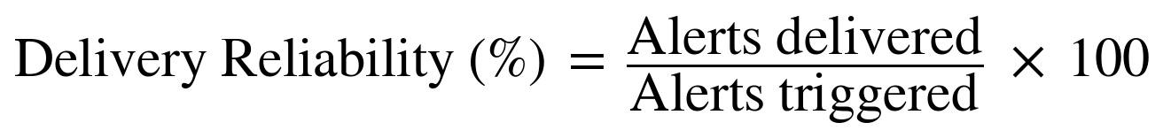

Recommendation-to-Execution Latency
Recommendation-to-execution latency is the time elapsed between the moment the decision algorithm determines a feeding action and the moment the actuator executes it, measured from the system's dispensing execution logs.
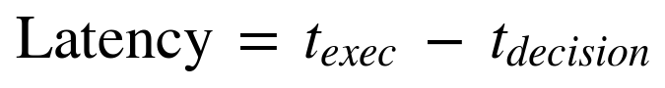

Design Trade-offs
The design of Tilapiers involves trade-offs between detection accuracy and computational cost, between Precision and Recall, and between the responsiveness and stability of the feeding decision. Table _ presents the comparison template for the candidate YOLOv8 variants. The values will be filled in after training and evaluation on the same dataset and test set, so that the variants can be compared under identical conditions.

Trade-off Analysis
The trade-off analysis will identify the YOLOv8 variant and operating parameters that best satisfy the requirements of the feeding decision. Larger variants generally achieve higher accuracy on small, densely packed objects at the cost of greater model size and slower inference, while smaller variants are faster but may miss closely clustered pellets. Since the feeding decision relies on pellet counts taken at the start and end of a five-minute observation window rather than on continuous high-frame-rate tracking, detection accuracy is weighed more heavily than raw speed, provided inference time on the deployed processing unit remains within the acceptable latency of the system.
The two types of detection error also carry different consequences because the depletion rate is computed as R = (P0 − Pt) / P0. Pellets missed at the end of the window (false negatives) lower Pt and cause depletion to be overestimated, which may allow feeding to continue while feed remains uneaten and risks water-quality degradation. Non-pellet objects counted as pellets (false positives) raise Pt and cause depletion to be underestimated, which may stop a session earlier than necessary. The researchers therefore treat Recall as the more consequential constraint because of the overfeeding risk, while requiring adequate Precision to avoid unnecessary session termination. The hard session dose ceiling (D_ref) and the confidence-based suppression of unreliable readings further bound the effect of residual detection errors. The final model and confidence threshold will be selected as the configuration that meets the target detection performance while remaining within the inference-time constraint of the deployed hardware.

Sensitivity Analysis
A sensitivity analysis will be conducted to determine how changes in the key parameters and in detection error affect the feeding outcome. Using recorded feeding-session data, the researchers will vary one parameter at a time while holding the others at their baseline values, and will re-run the decision algorithm on the recorded pellet counts to observe changes in the resulting depletion classification, the number of increments dispensed, and the total feed released. Table _ summarizes the parameters to be examined. The variation ranges shown are proposed starting points and may be adjusted during pilot calibration.

Parameter | Baseline | Proposed Variation | Outcome Observed
Detection confidence threshold | To be determined during validation | Increase and decrease around the baseline | Precision, Recall, pellet-count error, depletion class
High-depletion threshold | R ≥ 0.80 | 0.70, 0.75, 0.85, 0.90 | Proportion of windows classified High; total feed dispensed
Low-depletion threshold | R < 0.40 | 0.30, 0.35, 0.45, 0.50 | Proportion of windows classified Low; early stops and uneaten-feed alerts
Observation window | 5 minutes | 3 and 4 minutes (field range of 3–5 minutes) | Depletion rate and classification stability
Increment size | 0.25 × D_ref | Smaller and larger fractions of D_ref | Number of increments; uneaten feed per increment
Pellet-count error | Measured detector error | Simulated ±10% and ±20% error in Pt | Change in depletion class relative to ground truth
Table 5 Parameters for sensitivity analysis.
Parameters whose small variations change the depletion classification or the feed dispensed will be identified as sensitive and will be finalized through pilot calibration at the BFAR tank setup before the final evaluation.

Algorithm Implementation
The proposed Tilapiers system uses a sequential gate-then-detect approach that combines a rule-based environmental verification gate, a YOLOv8 model for feed-pellet detection and counting, and a rule-based, depletion-responsive feeding decision algorithm. The process begins with continuous polling of the water-temperature and dissolved-oxygen sensors. The environmental gate classifies the readings as Safe or Unsafe. If the environment is Unsafe, feeding is withheld and an SMS alert is sent to the caretaker. If the environment is Safe, a fixed-size feed increment is dispensed, and the YOLOv8 model counts the visible pellets within the feeding-zone ROI at the start and end of the observation window. The resulting depletion rate is classified as High, Moderate, or Low and determines whether the next increment is dispensed in full, dispensed at half size, or withheld. All readings, detections, decisions, and actions are logged and presented through the web dashboard.
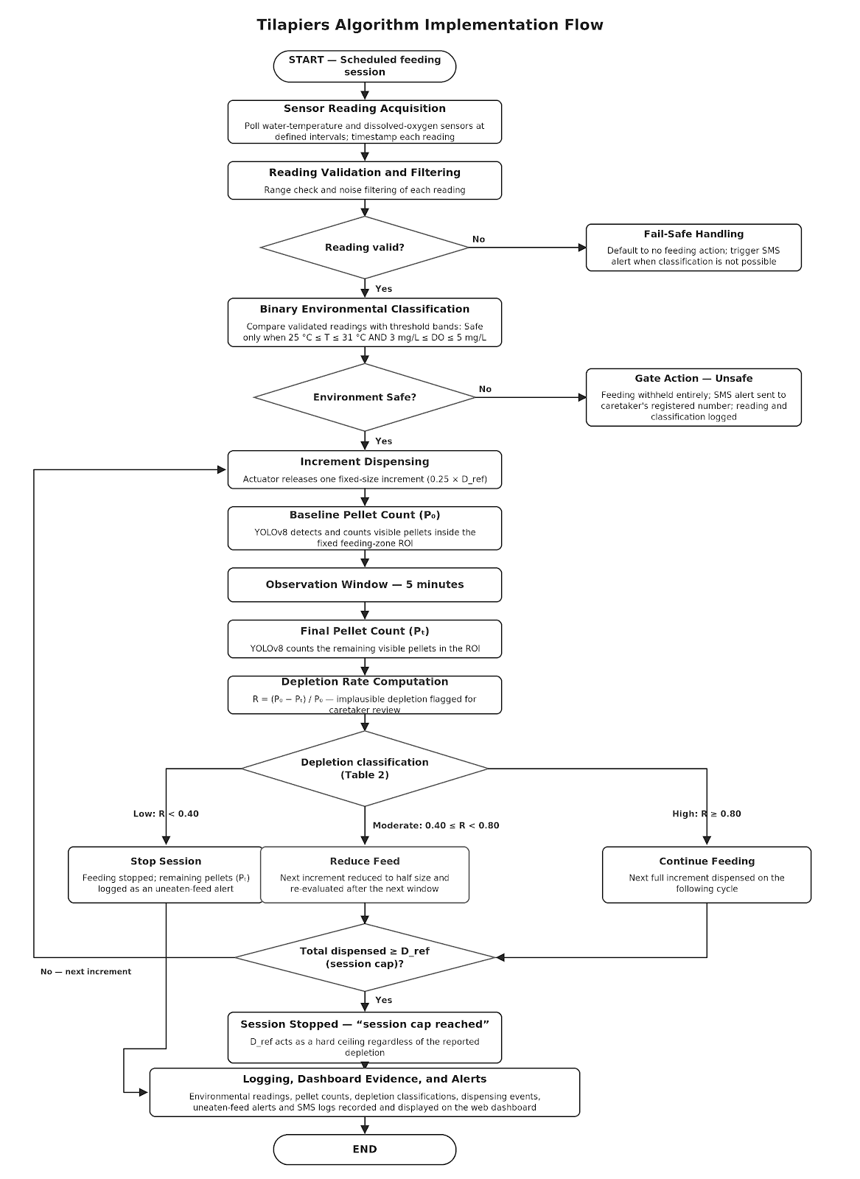
Figure 23 Tilapiers Algorithm Implementation Flow

Environmental Verification Gate
The environmental verification gate is the first stage of every feeding decision. It does not require model training because its decisions are based on the predefined threshold bands adopted for the study.

Step 1 - Sensor Reading Acquisition
The system polls the water-temperature sensor and the dissolved-oxygen sensor at defined intervals and timestamps each reading.

Step 2 - Reading Validation and Filtering
Each reading is checked for validity and filtered to reduce noise. An invalid or missing reading defaults the system to no feeding action and, where the failure prevents environmental classification entirely, triggers an SMS alert as a precaution.

Step 3 - Binary Classification
The validated readings are compared with the threshold bands in Table 1. The environment is classified as Safe only when the temperature is within 25 °C to 31 °C and the dissolved oxygen is within 3 mg/L to 5 mg/L simultaneously. If either parameter, or both, falls outside its range, the environment is classified as Unsafe. The parameters are not averaged or offset against each other.

Step 4 - Gate Action
When the state is Unsafe, feeding is withheld entirely, an SMS alert is sent to the caretaker's registered mobile number, and the readings and classification are logged. When the state is Safe, the feeding decision algorithm is engaged.

YOLOv8 Feed-Pellet Detection and Counting
YOLOv8 is used as the object detection component of Tilapiers. Its primary function is to detect and count visible feed pellets within the defined feeding-zone ROI after each dispensed increment. The model provides the location, class, and confidence of each detected pellet. It is engaged only after the environmental gate has classified the environment as Safe.

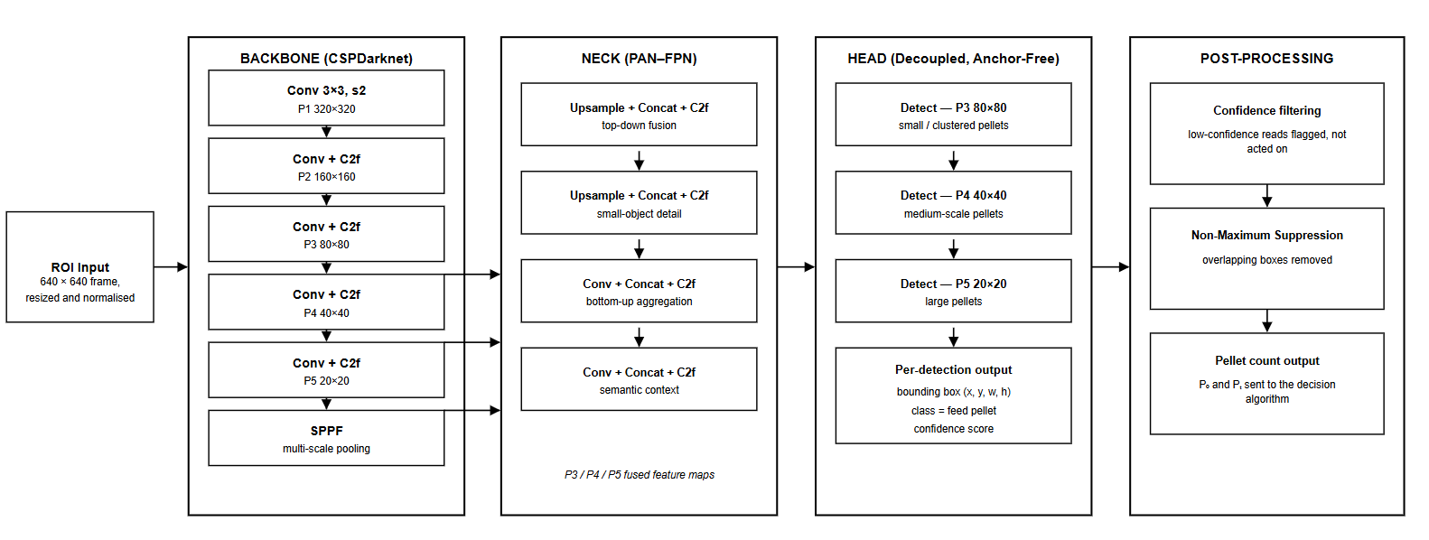
Figure 24 YOLOv8 Architecture

Step 1 - Video Frame Input
The camera module captures video of the feeding zone. Frames are sampled at the start and end of each observation window for pellet counting, and a corresponding frame or short clip is retained as detection evidence for the dashboard.

Step 2 - ROI Extraction
The frame is restricted to the fixed feeding-zone ROI so that only pellets within the defined region are counted. Because the camera position and ROI definition are fixed for the tank setup, the same region is evaluated consistently across sessions.

Step 3 - Image Preprocessing
The ROI image is resized and normalized according to the required YOLOv8 input format so that frames are processed consistently.

Step 4 - Feature Extraction
YOLOv8 processes the preprocessed image and extracts visual features that help distinguish feed pellets from the background, such as edges, shapes, textures, and colors.

Step 5 - Feature Processing
The extracted features are processed through the YOLOv8 network at different spatial scales. This allows the model to recognize small pellets, including those closely clustered together, amid water movement, air bubbles, and fish activity.

Step 6 - Pellet Detection
The YOLOv8 detection head generates predictions containing bounding boxes, the feed-pellet class label, and confidence scores.

Step 7 - Confidence Filtering
Predictions below the predefined confidence threshold are filtered out. Depletion readings that fall below the minimum detection-confidence threshold are suppressed: the system holds the previous state and flags a low-confidence read rather than feeding that reading into the decision logic.

Step 8 - Non-Maximum Suppression
Non-Maximum Suppression (NMS) is applied to remove redundant overlapping detections. When multiple bounding boxes represent the same pellet, the prediction with the higher confidence is retained.

Step 9 - Pellet Count Output
The remaining detections are counted to produce the pellet count for the frame. The counts at the start (P0) and end (Pt) of the observation window, together with the detection evidence, are forwarded to the feeding decision algorithm and the dashboard.

Depletion-Responsive Feeding Decision Algorithm
The feeding decision algorithm serves as the final decision-making component of Tilapiers. It combines the environmental gate's Safe/Unsafe state with the pellet counts from YOLOv8 to determine each feeding action. Like the environmental gate, it does not require model training because it operates on predefined conditions and thresholds.
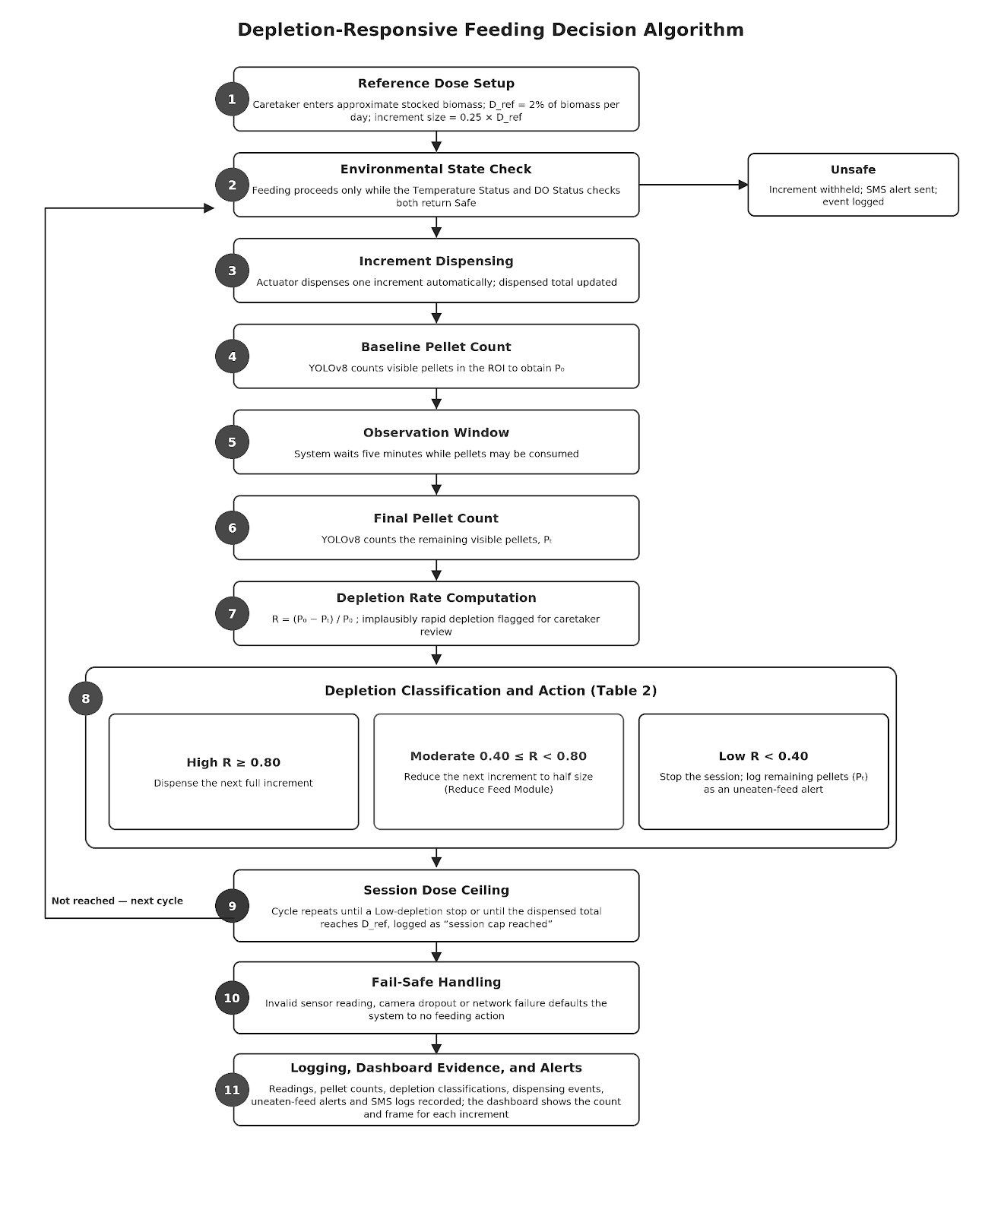
Figure 25 Depletion-Responsive Feeding Decision Algorithm

Step 1 - Reference Dose Setup
At stocking, the caretaker enters an approximate total stocked biomass, derived from an approximate fish count and the BFAR finisher-stage average body weight (256.5–361.5 g). The system computes the fixed reference starter dose (D_ref) at 2% of that approximate biomass per day, per BFAR-NCR extension guidelines. The dose remains fixed until the caretaker manually updates it, and the increment size is set to 0.25 × D_ref.

Step 2 - Environmental State Check
Before each increment is released, the current environmental state is verified. Feeding proceeds only if the state is Safe.

Step 3 - Increment Dispensing
The actuator automatically dispenses one increment without requiring caretaker approval, and the dispensed total is updated.

Step 4 - Baseline Pellet Count
After dispensing, YOLOv8 counts the visible pellets in the ROI to obtain the baseline count (P0).

Step 5 - Observation Window
The system waits for the defined five-minute observation window, during which the pellets may be consumed.

Step 6 - Final Pellet Count
At the end of the window, YOLOv8 counts the remaining visible pellets (Pt).

Step 7 - Depletion Rate Computation
The depletion rate is computed as R = (P0 − Pt) / P0. Implausibly rapid depletion, inconsistent with the expected depletion timeframes reported in the literature, is flagged for caretaker review rather than automatically classified as High depletion.
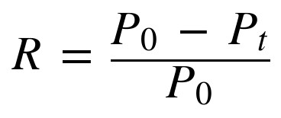

Step 8 - Depletion Classification and Action
The depletion rate is classified according to Table 2. If R ≥ 0.80, the depletion is classified as High and the next full increment is dispensed. If 0.40 ≤ R < 0.80, the depletion is classified as Moderate and the next increment is reduced to half size. If R < 0.40, the depletion is classified as Low, the session is stopped, and the remaining pellets (Pt) are logged as an uneaten-feed alert.

Step 9 - Session Dose Ceiling
The cycle repeats until the session ends by a Low-depletion stop or until the total dispensed feed reaches D_ref, at which point the session is stopped and logged as "session cap reached." The reference dose acts as a hard ceiling regardless of how consistently the detector reports high depletion.

Step 10 - Fail-Safe Handling
An invalid sensor reading, camera dropout, or network failure defaults the system to no feeding action.

Step 11 - Logging, Dashboard Evidence, and Alerts
The environmental readings, pellet counts, depletion classifications, dispensing events, uneaten-feed alerts, and SMS alert logs are recorded by the maintenance and logging module. The web dashboard displays the pellet count and the corresponding frame or short clip for each dispensed increment so that the caretaker can review what the system observed and acted on.

Model Training and Parameter Configuration
The YOLOv8 model will be trained using a custom feed-pellet dataset prepared by the researchers. Images will be captured from the fixed camera position over the feeding-zone ROI at the tank setup, before and after feed dispensing, and will cover the variations expected in operation, such as different times of day, lighting conditions, water clarity, pellet densities, and the presence of air bubbles, fish waste, reflections, and fish in the frame. Each visible feed pellet will be manually annotated with a bounding box under a single feed-pellet class. Objects that resemble pellets may be included as unlabeled background regions so that the model learns to distinguish them from actual pellets.
The dataset will be divided into training, validation, and testing sets to support model development and unbiased performance evaluation. To prevent near-identical consecutive frames from appearing in more than one set, the division will be made by feeding session or video rather than by individual frame. Data augmentation (for example, adjustments to brightness, contrast, blur, and orientation) will be applied to the training set only to improve robustness to lighting and water-clarity variation.
Training parameters such as learning rate, batch size, image size, number of epochs, and other applicable settings will be configured based on the requirements of the model. Pretrained YOLOv8 weights may be used and fine-tuned on the prepared dataset, and the candidate variants (for example, YOLOv8n, YOLOv8s, and YOLOv8m) will be trained under the same dataset and settings for the comparison in Table _. The training configurations may be adjusted based on the performance of the model on the validation set. The selected configuration will be the one that provides suitable validation performance while minimizing overfitting and meeting the inference-time constraint of the deployed hardware. The test dataset will remain separate from the training and validation datasets and will only be used for the final evaluation of the model.
The environmental verification gate and the depletion-responsive feeding decision algorithm do not require model training because they operate using predefined conditions. Their threshold values (temperature and dissolved-oxygen bands, depletion-rate tiers, increment size, and observation window) are based on the sources identified in the planning phase and will be refined through the study's pilot calibration and sensitivity analysis.

Testing and Operating Procedure

Testing Strategy
Testing follows the test-level structure defined in ISO/IEC/IEEE 29119, applied across both the software and the integrated hardware-software system, and is further organized around the ISO/IEC 25010 quality characteristics for non-functional verification. Table 3.3 summarizes the testing strategy.
Test Level / Characteristic | Technique | Target Component | Acceptance Basis
Unit Testing | Automated test scripts (per-function assertions), run via CI/CD on every commit. | Individual decision-algorithm functions, sensor-reading parsers, API handlers. | All unit tests pass; no unhandled exceptions on boundary values (e.g., R = 0.8, R = 0.4).
Integration Testing | Controlled test harness feeding synthetic sensor values and pellet counts into the pipeline. | Temperature/DO Monitoring-to-Status path; Fish Feeding Evaluation-to-Safe Feeding Execution path; Safe Feeding Execution/Reduce Feed-to-actuator path. | Correct state transitions (Safe/Unsafe; High/Moderate/Low depletion) for all defined input combinations in Tables 1 and 2, Chapter 1.
System Testing (end-to-end) | Scripted operational scenarios executed on the fully assembled prototype at the BFAR tank. | Full feeding session from Water Temperature/DO Monitoring through Fish Feeding Evaluation, Safe Feeding Execution (or Reduce Feed), dashboard update, and SMS dispatch via the Temperature/DO Status modules. | Observed system behavior matches the documented algorithm and Table 2 response classification for each scenario.
Functional Suitability (ISO/IEC 25010) | Requirements traceability check against the SRS. | All operational modules listed in Table 3.1, including Profile Management, Maintenance, and Security. | Every functional requirement in the SRS is traceable to an implemented and tested feature.
Performance Efficiency | Latency benchmarking (recommendation-to-execution). | Decision engine, actuator command path. | Latency within the threshold defined for Objective 5.
Usability | System Usability Scale (SUS) administered to a subset of evaluators; heuristic walkthrough. | Web dashboard. | SUS score interpreted per standard SUS bands (Above Average or higher).
Reliability | Extended uptime observation; forced sensor/camera dropout tests. | Full system. | System defaults safely to no-feeding action on any dropout, per the fail-safe delimitation in Chapter 1.
Security | Authentication and access-control review of the dashboard and API. | Main Menu/Authentication Module and Profile Management Module access control; backend API endpoint protection. | No unauthenticated access to control endpoints; caretaker data (mobile number, biomass estimate) stored with basic access controls.
Table 6 Testing Strategy by Level and ISO/IEC 25010 Characteristic

Validation of Strategy Employed
- Detection validation: YOLOv8 pellet counts on the held-out test set are compared against manually verified ground-truth counts to compute precision, recall, F1-score, mAP, and a confusion matrix, directly operationalizing Objective 5's detection-performance requirement.
- Sensor validation: Temperature and DO readings are cross-checked against calibrated reference instruments at multiple points across the operating range, with percent error computed and any drift corrected before field deployment (Section 3.4.2).
- Depletion-tracking validation: Pellet-depletion rate computed by the vision pipeline is compared against a manually observed depletion count within the same observation window, following the same validation logic applied by Riyandani et al. (2023), to quantify how closely the vision-derived proxy tracks the manually verified ground truth, per Objective 5.
- Alerting validation: SMS delivery success rate and delivery latency are logged across repeated forced-Unsafe test conditions to validate the reliability of the third-party SMS gateway/GSM module, acknowledging the delimitation that ultimate delivery still depends on cellular network availability at the deployment site.
- End-to-end latency validation: Timestamps are logged at each pipeline stage (sensor read → classification → detection → decision → actuator execution) to compute recommendation-to-execution latency under normal operating load.

System Operating Procedure (revised step references)

Initial setup: via the Main Menu and Authentication Module, the caretaker logs in and enters the stocked biomass estimate and registered mobile number.

Reference dose computation: the system computes D_ref from the entered biomass, per BFAR-NCR guidelines.

Continuous background monitoring: the Water Temperature Monitoring and Dissolved Oxygen Monitoring modules poll continuously; the Temperature Status and DO Status modules classify each as Safe/Unsafe and alert the caretaker via SMS if Unsafe.

Feeding evaluation: one hour before a scheduled session, the Fish Feeding Evaluation Module checks both status classifications; if both are Safe, control passes to the Safe Feeding Execution Module.

Automated feeding when Safe: the Safe Feeding Execution Module dispenses the reference dose in fixed increments, using YOLOv8 pellet detection to compute depletion rate; Moderate depletion routes to the Reduce Feed Module, Low depletion stops feeding.

Alerting when Unsafe: if either environmental check fails, feeding is withheld, the event is logged, and an SMS alert is sent.

Caretaker review: the caretaker reviews logs and alerts via the dashboard, and manages staff/security functions through the Profile Management and Security modules as needed.

Dose update after restocking: the caretaker re-enters the biomass estimate to recompute D_ref.

Project Evaluation
Project evaluation measures the system's quality as perceived by projected end-users and subject-matter experts, complementing the objective technical benchmarks obtained during testing (Section 3.5). Evaluation follows ISO/IEC 25010:2011 as its structuring standard, consistent with Objective 5 of Chapter 1.
Evaluators. Thirty (30) evaluators are recruited via purposive sampling into three groups of ten: IT/software engineering experts, BFAR-NCR/aquaculture technical personnel, and prospective end-users (tilapia farmers and hobbyists), as described in Section 3.1.
Instrument. A researcher-made questionnaire anchored on the eight ISO/IEC 25010 quality characteristics — functional suitability, performance efficiency, compatibility, usability, reliability, security, maintainability, and portability — is administered using a five-point Likert scale (5 = Strongly Agree/Excellent to 1 = Strongly Disagree/Poor).
Procedure. Each evaluator receives a live demonstration and a supervised hands-on session with the deployed prototype at the BFAR tank (or, where field access is impractical, a recorded demonstration and a dashboard walkthrough), followed by questionnaire administration and an open-ended feedback item.

Weighted Mean Range | Verbal Interpretation | Statistical Treatment
4.20 – 5.00 | Excellent
3.40 – 4.19 | Very Satisfactory | Weighted mean per ISO/IEC 25010 characteristic and overall; standard deviation to gauge rating consistency across the three evaluator groups; one-way ANOVA (or Kruskal–Wallis, if data are non-normal) to test whether ratings differ significantly across groups.
2.60 – 3.39 | Satisfactory
1.80 – 2.59 | Fair
1.00 – 1.79 | Poor
Table 7 Statistical Treatment and Verbal Interpretation Scale for Project Evaluation

Work Plan (Work Breakdown Structure)
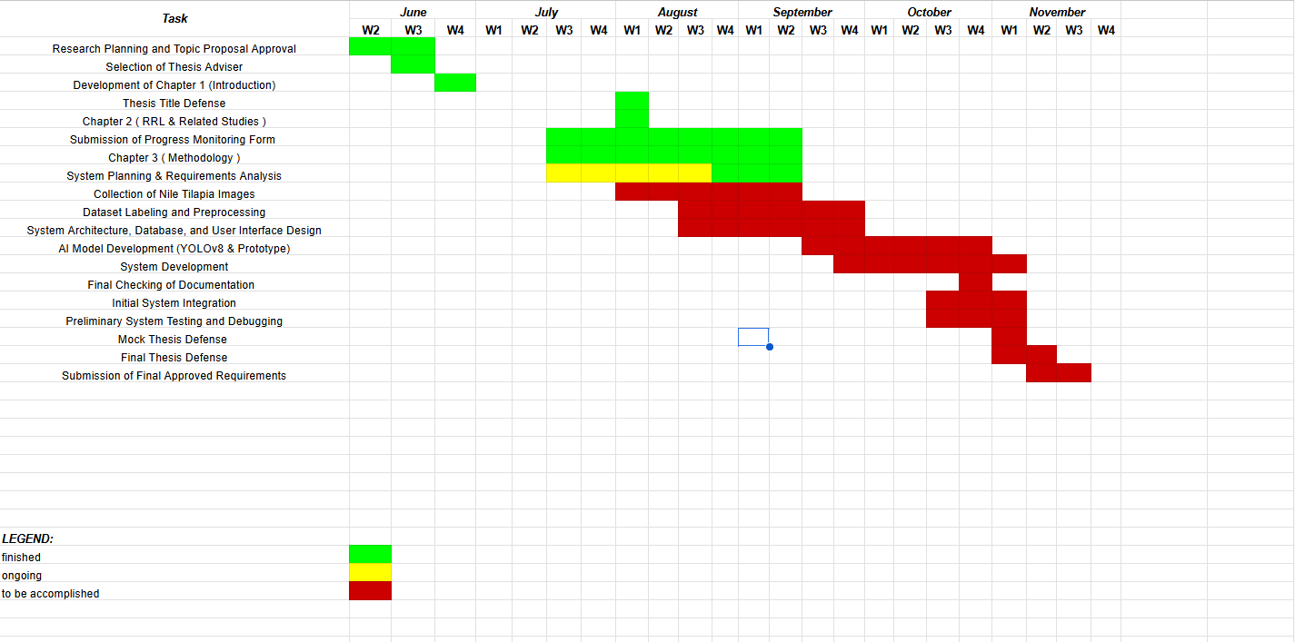

Figure 26 Gantt Chart
The Gantt Chart presents the updated Work Breakdown Structure (WBS) for the project’s estimated twenty-four-week development timeline. It outlines the scheduled activities and target periods for each major phase, including research planning and proposal approval, thesis chapter preparation, system planning and requirements analysis, Nile tilapia image collection, dataset labeling and preprocessing, system architecture and user interface design, AI model development using YOLOv8, system development, system integration, testing and debugging, documentation, thesis defense, and submission of the final approved requirements. The Gantt chart also uses color coding to indicate completed, ongoing, and pending activities, providing a clear overview of the project’s progress and remaining tasks.

Potential for Commercialization
This section evaluates Tilapiers’ potential to become a commercially viable system beyond its use as a thesis prototype by examining its target market, competitive advantages, product development roadmap, go-to-market strategy, and proposed business model.

Market Model
Nile tilapia is the Philippines' second most-farmed aquaculture species, with the sector contributing 304,326.59 metric tons — roughly 6.91% of the country's total fisheries production — in 2020, produced across 60,056 registered grow-out farms and 623 hatcheries nationwide, the majority privately owned (Bureau of Fisheries and Aquatic Resources [BFAR] & Department of Agriculture [DA], 2022). Central Luzon alone accounts for 45.71% of national tilapia production, followed by CALABARZON at 23.84% (BFAR & DA, 2022). Feed is consistently reported as the single largest cost driver in tilapia production, accounting for approximately 56.9% to 68% of total production cost depending on farm scale and region (BFAR & DA, 2022) — the specific inefficiency Tilapiers' depletion-responsive dosing is designed to reduce. This directly supports the market-sizing logic below.
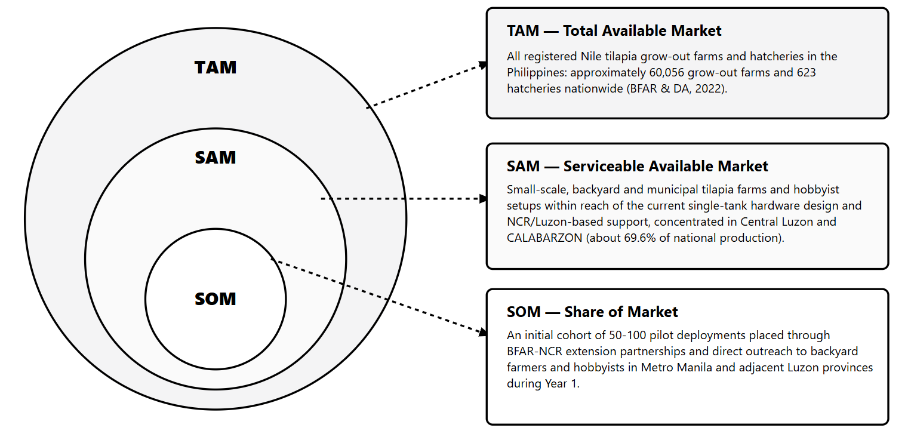
Figure 27 Market Model
These figures are drawn from the Philippine Tilapia Industry Roadmap 2022–2025 (BFAR & DA, 2022) and should be revisited against more recent Philippine Statistics Authority and BFAR releases as they become available, since industry figures are updated periodically and the roadmap's own base year is 2020.

Measurable Benefits
Tilapiers' central differentiator is that it converts feeding — the single largest and most variable cost component in tilapia production — from a schedule- or judgment-based practice into a closed-loop, observation-driven process gated on measured environmental safety. Its measurable benefits to buyers/users include:
- Reduced feed wastage: By continuing, halving, or stopping increments based on observed pellet depletion rather than dispensing a full ration regardless of appetite, the system targets the overfeeding losses identified in Chapter 1 as a major contributor to the feed cost that already represents 56.9%–68% of total production cost (BFAR & DA, 2022).
- Improved water-quality outcomes: Uneaten-feed flagging and the environmental safety gate reduce the incidence of decomposing excess feed, a key driver of bacterial loading and mortality risk described in Chapter 1.
- Reduced feeding losses during unsafe conditions: Feeding is automatically withheld — rather than continued out of habit or a rigid schedule — when temperature or dissolved oxygen falls outside the optimal range, avoiding feed loss and stress-related mortality during thermal or hypoxic stress.
- Labor and attention savings: Automated dosing and SMS alerting remove the need for a caretaker to be physically present to judge appetite or check water parameters before every feeding session.
- Accessibility for non-specialist users: Hobbyists and small-scale farmers gain access to an automated safeguard against overfeeding without needing laboratory-grade measurement equipment or aquaculture expertise, consistent with the Significance section of Chapter 1.

Three-Year Product Roadmap

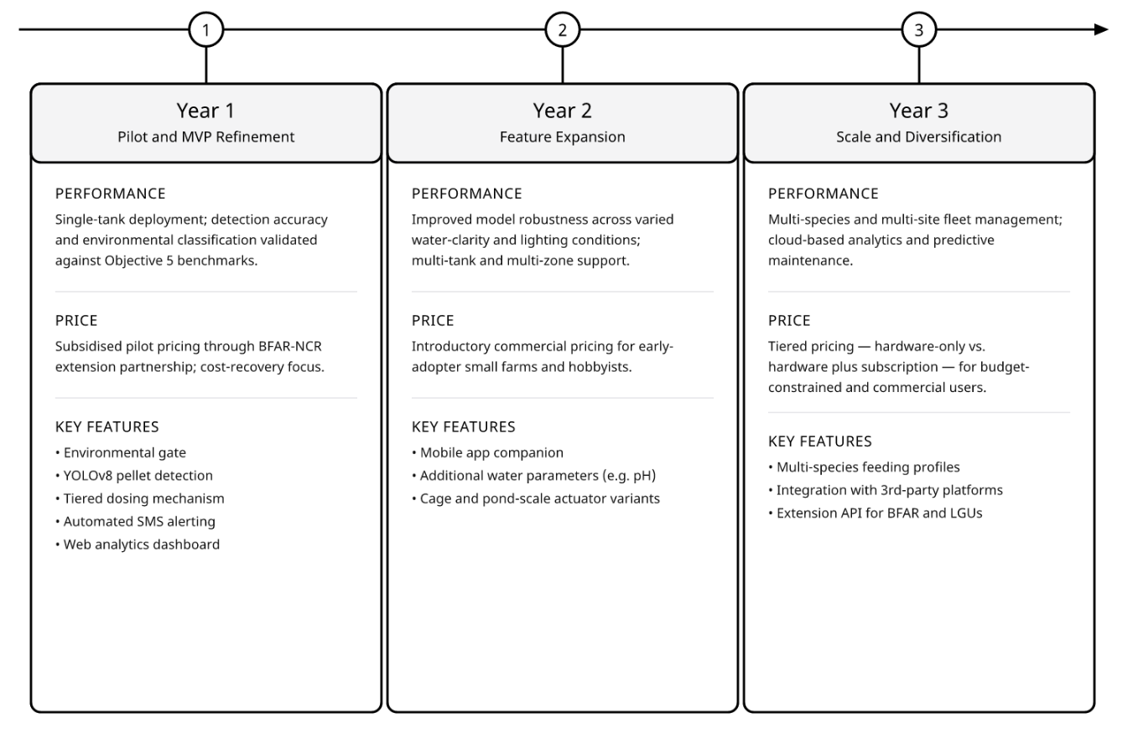Figure 28 Three-Year Product Roadmap
Figure 28 presents a three-year product roadmap divided into three distinct development phases: Year 1 (Pilot and MVP Refinement), Year 2 (Feature Expansion), and Year 3 (Scale and Diversification). Year 1 focuses on single-tank deployment, subsidised pilot pricing through BFAR-NCR, and core capabilities such as YOLOv8 pellet detection and automated SMS alerting. Year 2 expands functionality by introducing multi-tank support, introductory commercial pricing, a mobile app companion, and additional water parameter sensors like pH. Finally, Year 3 aims at full scaling through multi-species fleet management, cloud-based predictive analytics, tiered subscription pricing, and third-party extension APIs.

Go-to-Market Strategy
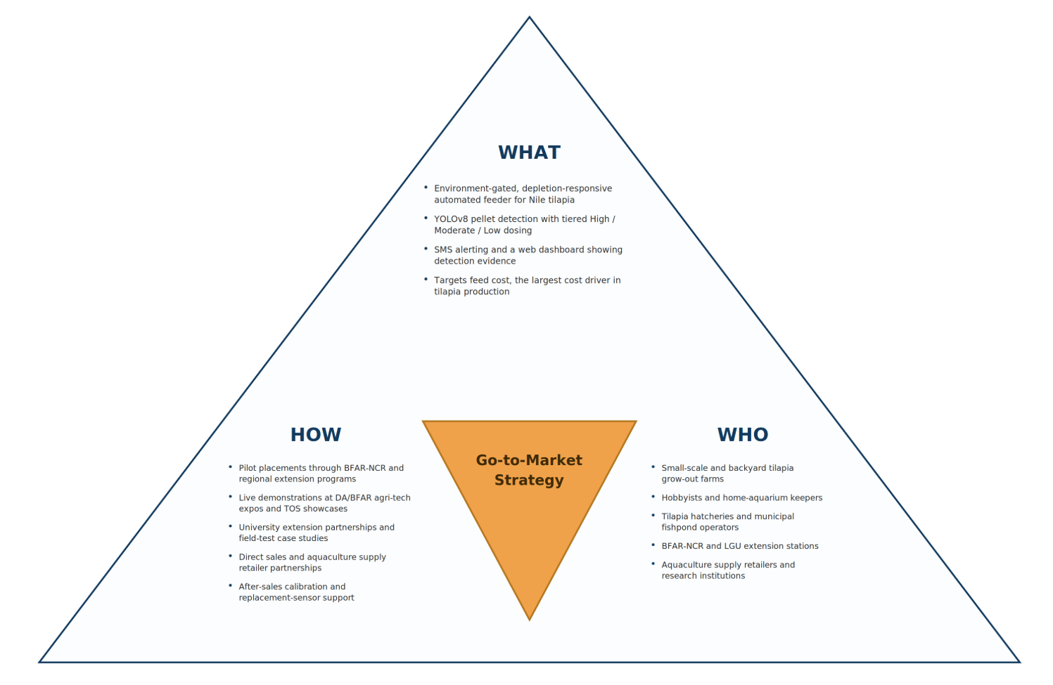
Figure 29 Go to Market Strategy

Distribution channels: Initial distribution through BFAR-NCR and BFAR regional extension programs, which already reach the study's identified beneficiary groups (tilapia farmers, hobbyists, and the aquaculture industry under BFAR-NCR); complemented by direct sales to backyard/hobbyist buyers and partnerships with aquaculture supply and hardware retailers.
Marketing programs: Live demonstrations at agricultural and agri-tech expos (e.g., DA/BFAR-organized events), technology outreach station (TOS) showcases, and university extension partnerships; case-study content built from the system's own field-testing results (Section 3.4.7) to demonstrate measurable feed-cost and water-quality benefits.
Marketing plans: A phased plan aligned to the product roadmap — pilot placements and BFAR endorsement in Year 1, targeted outreach to Central Luzon and CALABARZON small-scale farms (the two highest-producing regions per BFAR & DA, 2022) in Year 2, and broader e-commerce and reseller-network expansion in Year 3.
Other marketing concerns: Given that most target farms are small-scale and cost-sensitive, messaging emphasizes total feed-cost savings and water-quality risk reduction over technical specifications, and after-sales support (calibration assistance, replacement sensors) is positioned as part of the value proposition given the field's reliance on continuous, dependable operation.

Business Model
Value Chain Position. Tilapiers positions itself as an input-supply-stage technology provider within the tilapia value chain described by BFAR and DA (2022) — alongside feed and equipment suppliers — rather than as a producer, processor, or trader, supplying a device-plus-software layer that improves feed-input efficiency at the farm-production stage.
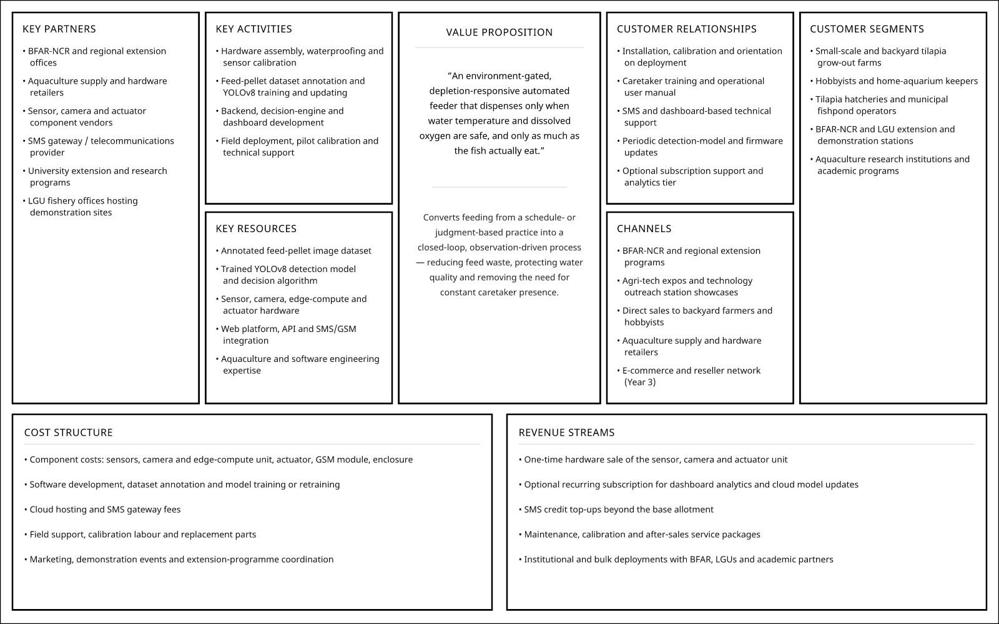
Figure 30 Business Model Summary
Overall, Tilapiers' commercialization case rests on addressing a cost driver — feed, at 56.9%–68% of production cost (BFAR & DA, 2022) — that is both large and directly observable through the system's own telemetry, giving any future pilot a straightforward basis for demonstrating return on investment to prospective adopters.

References

Bureau of Fisheries and Aquatic Resources Regional Office No. 8. (n.d.). Tilapia in ponds [Techno Guide Series flyer]. Department of Agriculture, Bureau of Fisheries and Aquatic Resources.
Department of Environment and Natural Resources. (2016). DENR Administrative Order No. 2016-08: Water quality guidelines and general effluent standards of 2016. Department of Environment and Natural Resources, Republic of the Philippines.
Abrajano, J. V., Apanay, J., Botangen, K. A., Nabua, J., & Peña, C. F. (2024). IoT-based water quality monitoring system in Philippine off-grid communities. arXiv. https://arxiv.org/abs/2410.14619
Cai, C., Tan, S., Wang, X., Zhang, B., Fang, C., Li, G., Xu, L., Liu, S., & Wang, R. (2025). Real-time detection of hypoxic stress behavior in aquaculture fish using an enhanced YOLOv8 model. Aquaculture International, 33, Article 207. https://doi.org/10.1007/s10499-025-01886-0
Chen, C. H., Wu, Y. C., Zhang, J. X., & Chen, Y. H. (2022). IoT-based fish farm water quality monitoring system. Sensors, 22(17), Article 6700. https://doi.org/10.3390/s22176700
Hamed, S. A., El-Kassas, S., Abo-Al-Ela, H. G., Abdo, S. E., Abou-Ismail, U. A., & Mohamed, R. A. (2024). Temperature and feeding frequency: Interactions with growth, immune response, and water quality in juvenile Nile tilapia. BMC Veterinary Research, 20, Article 528. https://doi.org/10.1186/s12917-024-04366-4
Hossam, R., Heakl, A., & Gomaa, W. (2024). Precision aquaculture: An integrated computer vision and IoT approach for optimized tilapia feeding (arXiv:2409.08695). arXiv. https://arxiv.org/abs/2409.08695
Islam, S. M. M., Akhter, F., Jahan, I., Rashid, H., & Shahjahan, M. (2022). Alterations of oxygen consumption and gills morphology of Nile tilapia acclimatized to extreme warm ambient temperature. Aquaculture Reports, 23, Article 101089. https://doi.org/10.1016/j.aqrep.2022.101089
Jocher, G., Chaurasia, A., & Qiu, J. (2023). Ultralytics YOLOv8 (Version 8.0.0) [Computer software]. GitHub. https://github.com/ultralytics/ultralytics
Liu, R., Liu, R., Song, G., Li, Q., Cui, Z., & Long, Y. (2022). Mitochondria dysfunction and cell apoptosis limit resistance of Nile tilapia (Oreochromis niloticus) to lethal cold stress. Animals, 12(18), Article 2382. https://doi.org/10.3390/ani12182382
Qian, R., Deng, H., Wang, Z., Zhou, L., Li, B., He, J., & Ling, J. (2026). Real-time detection of fish feeding behavior with PM-YOLO utilizing YOLOv8. Discover Applied Sciences, 8, Article 48. https://doi.org/10.1007/s42452-025-08043-5
Refaey, M. M., Zghebr, F. E., Mansour, A. T., & Mehrim, A. I. (2025). Effect of different aquaculture systems on chronic hypoxia tolerance in Nile tilapia, Oreochromis niloticus: Growth rate, physiological responses, oxidative stress biomarkers, and flesh quality. Aquaculture International, 33, Article 130. https://doi.org/10.1007/s10499-024-01799-4
Riyandani, M., Jaya, I., & Pujiyanto, A. (2023). Computer vision-based fish feed detection and quantification system. Jurnal Akuatika Indonesia, 8(1), 833–840. https://doi.org/10.30871/jagi.v7i1.5644
Romero, A. A., Dela Cruz, K., Ocampo, D., Palabasan, G., Salac, M. A., Sison, V. K., & Trinidad, E. (2023). Nile tilapia size estimation and tracking using YOLOv5 and DeepSORT. International Journal of Progressive Research in Science and Engineering, 4(8), 1–8. https://journal.ijprse.com/index.php/ijprse/article/view/959
Sangkaphet, P., Chansiri, N., Kaewklom, C., Chaleamwong, B., Wonglamai, P., Chinnachot, P., & Makdee, S. (2026). The development and field evaluation of an IoT–LoRa-based water-quality-monitoring and aeration-actuation system for tilapia cage farming. Applied Sciences, 16(11), Article 5308. https://doi.org/10.3390/app16115308
Zhang, L., Zheng, Y., & Liu, Z. (2025). A method for detecting feeding fish in ponds based on FFishNet-YOLOv8. Computers and Electronics in Agriculture, 230, Article 109873. https://doi.org/10.1016/j.compag.2024.109873

